Natural Resources Data Visualization Training Using Google Data Studio in Triharjo Village, Merbau Mataram District, South Lampung Regency

Luluk Muthoharoh | Mika Alvionita S | Christyan Tamaro Nadeak
Sumatera Institute of Technology  INDONESIA | Sumatera Institute of Technology  INDONESIA | Sumatera Institute of Technology  INDONESIA

Tirta Setiawan | Febri Dwi Irawati
Sumatera Institute of Technology  INDONESIA | Sumatera Institute of Technology  INDONESIA

Article Info |  | Abstract
Article history:  Received: Month XX, 20XX  Revised: Month XX, 20XX  Accepted: Month XX, 20XX  (Cambria 9) |  | Many data processing applications help to present and report data. One of the digital tools that is quite widely used is Google Data Studio. This Community Service activity aims to provide data visualization training to Triharjo Village, one of the villages that still does not use digitalization to access village data online. Natural Resources Data Visualization Training Using Google Data Studio in Triharjo Village, Merbau Mataram District, South Lampung Regency has been successfully implemented. This activity is very necessary to facilitate the monitoring of agricultural products from Triharjo Village on the dashboard via the village website. With this training, it is hoped that it can help manage natural resource data which will help village officials and village communities, teachers and students in providing information services related to data visualization.
Keywords:
Dashboard
Google data studio
Training
Visualization
To cite this article: Author. (20XX). Title. Smart Society : Community Service and Empowerment Journal, X(X), XX-XX

INTRODUCTION
Data visualization is a technique used to communicate data and information and then create it into visual objects (Loka & Natalia, 2019; Mohammad H et al., 2022; Saputri & Muharni, 2021). As with communication, success or failure is determined by how the speaker conveys the information given to the person he is speaking to, the same goes for data visualization. Good visualization provides clear and more focused answers (Ali & Menap, 2021; Phatcharanat et al., 2023). Data visualization in this era has a lot of output and can explain the data accurately (Fernando, 2018). The purpose of data visualization itself is to convey information concisely and clearly to readers through services that are widely available.
One service for visualizing data is Google Data Studio. Google Data Studio is a service created by Google to manage data. One of the data processing in Google Data Studio is visualizing data in the form of graphs or diagrams so that it is easier to draw conclusions (Hayati et al., 2021; Jayanti & Ani, 2017). Research regarding the use of Google Data Studio was carried out by Fernando in visualizing sales data which resulted in the conclusion that Google Data Studio has support for various data sources, making it easy to integrate company reports (Fernando, 2018). Research on the use of Google Data Studio was also carried out by Hayati et.all who applied Google Data Studio to visualize student E-reports at SMAN 2 Balikpapan (Hayati et al., 2021) and Sugiarto, et al (2021) who applied Google Data Studio to the price and supply of rice at the Rice Main Market Cipinang (Sugiarto et al., 2021). So in this era of digitalization, it requires everyone to be able to access and obtain data online (Setiawan, 2017).
One way to access data online is using a dashboard (Dewi et al., 2013; Handayani et al., 2017). The development of dashboards in Industry 4.0 is increasingly rapid where almost all people use technology for information about villages (Devianto & Dwiasnati, 2021). The village community needs a dashboard to find out information about the village. Few (2006) explains that dashboards function to convert repository data into information that is easy to consume (Sugiarto et al., 2021). Triharjo Village in South Lampung still does not have a dashboard to introduce the village's abundance of natural resources which will make it easier for the community to understand the agricultural potential of Triharjo Village.
Aware of these problems, this community service will be implemented which is expected to increase knowledge in terms of data visualization with Google Data. So, we are from the Data Science Study Program of the Sumatra Institute of Technology plan to provide Community Service by providing training to village officials so they can use Google Data Studio as a medium for visualizing data with Google Data Studio which is very necessary to facilitate monitoring of agricultural products from Triharjo Village on the dashboard via village website.
Many have not been able to visualize data using Google Data Studio and display it in the Dashboard on the village website which is also a tool for evaluating village systems. Processing data recaps in villages which is carried out manually has difficulties in identifying opportunities for villages to develop based on data that already exists in the village. Therefore, the target in community service functions to provide problem solving to problems that occur with partners, namely in the form of: 1. Introduce the Tiharjo village community to the importance of digitizing performance dashboards. 2. Teach how to use Google Data Studio tools which can be used to help with the process of creating Dashboards.

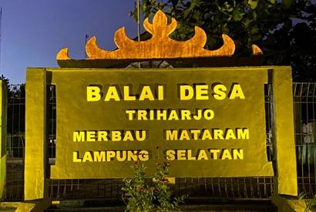
Figure 1. Triharjo Village

METHOD
The method of implementing community service consists of several stages which can be seen in the flow diagram in Figure 2 below:
- Identify partner problems
At this stage, the team identifies relevant stakeholders who will be involved in applying the technology to partners.
- Identify partner needs
This stage, the team examines in more depth the relationship between existing problems with partners and the suitability of existing technology by the Team and stakeholders.
- Design and adjustment
This is the data visualization training stage with Google Data Studio and continues after the dashboard has been created according to partner needs. At this stage all parameters related to the problem and solution must be truly appropriate.
- Test the dashboard
The dashboard product trial will involve partners as users, and at this stage the team will also carry out important evaluations regarding the stability and ease of use of the technology for partners.
- Training and mentoring
The mentoring process is carried out during and after the trial.
- Handover of the dashboard
The handover is carried out at the end after the partner really feels the benefits of information technology in the form of a dashboard.

Identify partner problems

Identify partner needs

Training and mentoring
Test the dashboard

Design and adjustment

Handover of the dashboard

Figure 2. Flow chart of the method

RESULTS AND DISCUSSION
The implementation of Community Service (PKM) by Data Science lecturers at the Sumatra Wacana Institute of Technology was carried out for one day, Sunday, August 24 2023. However, before that, a site survey had been carried out first on June 20 2023. The activity was carried out at the Balai office of Triharjo Village. The training was attended by 10 (ten) participants consisting of village officials. The mentoring process for using the Google Data Studio application was carried out by Rizty Maulida Badri, M.Si who is a lecturer from the Data Science Study Program. The speaker explains data visualization, then explains how to use the Google Data Studio application and how to display it on the village website. In the introduction to Google Data Studio, the presenter asked participants to access the page https://datastudio.google.com, then the presenter explained the features of Google Data Studio. After that, participants practiced using the Google Data Studio application using examples of natural resource data from Triharjo Village.
The data is written and processed using Microsoft Excel, then uploaded to Google Drive. After the data is uploaded, it can then be used in Google Data Studio. This data is then made into data that is visually more attractive, clearer and more specific. The visualization carried out is changing rigid table data into graphs, diagrams, and so on. This graph is able to show changes and differences in data more clearly. As a result, the display of data resulting from regular statistical analysis becomes more beautiful with eye-catching visuals using interactive dashboard options (Saepuloh, 2020).
Apart from that, participants were also given knowledge about how to share the results of data visualizations that have been created, including how to change the rules in Google Data Studio regarding data management. Data management includes who can view, edit data and so on. Then participants also learned how to download the data results that had been created in Google Data Studio. So far, data reporting is still done face to face between village officials, giving rise to a lack of openness towards the community.


Figure 3. Providing Training by the Presenter

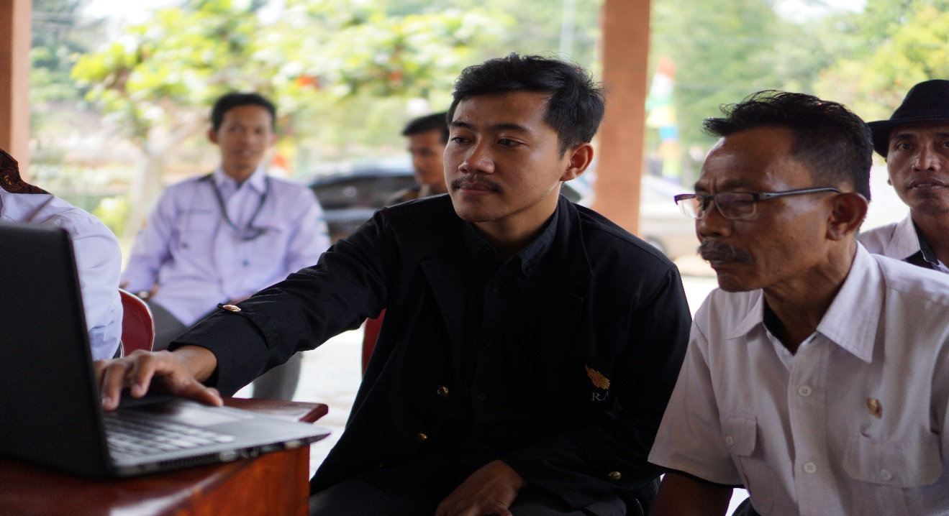
Figure 4. Participants Visualize the Distribution of Natural Resources Data using Google Data Studio
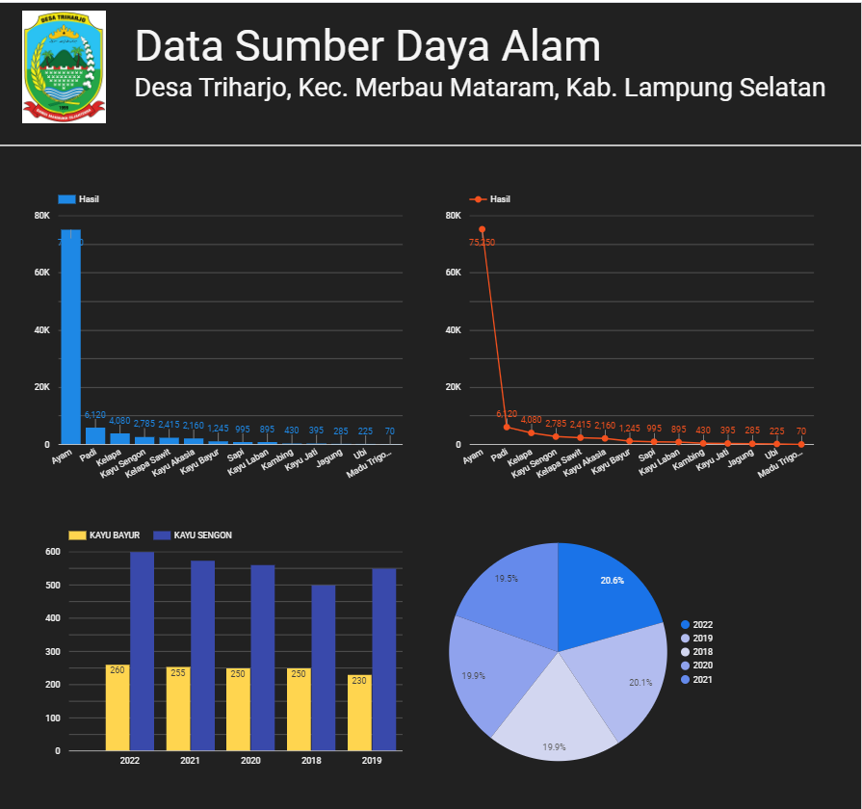

Figure 5. Dashboard display

CONCLUSION
Natural Resources Data Visualization Training Using Google Data Studio in Triharjo Village, Merbau Mataram District, South Lampung Regency has been successfully implemented. This activity is very necessary to facilitate monitoring of agricultural products from Triharjo Village on the dashboard via the village website. The target for community service has also been achieved and serves to provide problem solving for problems that occur with partners, namely in the form of: 1. Introducing the Tiharjo village community to the importance of digitizing performance dashboards. 2. Teach how to use Google Data Studio tools which can be used to help with the process of creating Dashboards. With this training, it is hoped that it can help manage natural resource data which will really help village officials and village communities, teachers and students in providing information services related to data visualization.

REFERENCES
Ali, M., & Menap, M. (2021). Workshop Pengumpulan dan Visualisasi Data Online Survei Kepuasan Masyarakat terhadap Pelayanan Puskesmas di Lombok Tengah. Abdimas: Jurnal Pengabdian Masyarakat Universitas Merdeka Malang, 6(2), 279–289. https://doi.org/10.26905/abdimas.v6i2.5384
Devianto, Y., & Dwiasnati, S. (2021). Rancang Bangun Web Portal Berita Sebagai Sumber Informasi Berita Tentang Pertanian. JATISI (Jurnal Teknik Informatika Dan Sistem Informasi), 8(2), 534–546. https://doi.org/10.35957/jatisi.v8i2.792
Dewi, M., Suliyanih, & Marlieana, J. (2013). Dashboard Sistem Informasi Keuangan Dalam Mendukung Proses Pengambilan Keputusan. In Seminar Nasional Teknologi Informasi dan Multimedia (pp. 17–189).
Fernando, D. (2018). Visualisasi Data Menggunakan Google Data Studio. Jurnal Pengabdian Masyarakat, 2(1), 71–77. https://e-jurnal.lppmunsera.org/index.php/snartisi/article/view/808
Handayani, I., Kusumahati, H., & Badriah, A. N. (2017). Pemanfaatan Google Spreadsheet Sebagai Media Pembuatan Dashboard pada Official Site iFacility di Perguruan Tinggi The Use of Google Spreadsheet as Dashboard Making Media on iFacility Official Site in Higher Education. Jurnal Ilmiah SISFOTENIKA, 7(2), 177–186.
Hayati, F. N., Silfiani, M., & Nurlaily, D. (2021). Pemanfaatan Google Data Studio Untuk Visualisasi E-Rapor Siswa Sman 2 Balikpapan. Jurnal Pengabdian Kepada Masyarakat ITK (PIKAT), 2(2), 87–94. https://doi.org/10.35718/pikat.v2i2.619
Jayanti, E. D., & Ani, N. (2017). Pembangunan Dashboard Untuk Visualisasi Analisa Keuangan. Jurnal, 6, 2089–5615.
Loka, W. I., & Natalia, F. (2019). Perancangan dan Pembuatan Visualisasi Data Dana Penelitian Internal dan Hibah Dikti LPPM Universitas Multimedia Nusantara. Ultima InfoSys : Jurnal Ilmu Sistem Informasi, 10(1), 61–68. https://doi.org/10.31937/si.v10i1.867
Mohammad H, A., Masooma, K., Fatima, S., & Fatima, M. (2022). Data Visualization and Statistical Graphics in big data analysis by Google Data Studio - Sales Case Study. 2022 IEEE Technology and Engineering Management Conference: Societal Challenges: Technology, Transitions and Resilience Virtual Conference, TEMSCON EUROPE 2022, 228–234.
Phatcharanat, S.-O., Noraset, T., & Somchat, S. (2023). Development of monitoring PM2.5 based on IoT and Google Data Studio. Proceeding - 2023 International Electrical Engineering Congress, IEECON 2023, 64–67.
Saepuloh, D. (2020). Visualisasi Data Covid 19 Provinsi DKI Menggunakan Tableau. Jurnal Riset Jakarta, 13(2), 55–64. https://doi.org/10.37439/jurnaldrd.v13i2.37
Saputri, T. A., & Muharni, S. (2021). Penerapan Media Pembelajaran Daring dalam Kegiatan Belajar Mengajar pada IAIN Metro. Jurnal Pusat Pengabdian Kepada Masyarakat ), 5(2), 37–44.
Setiawan, W. (2017). Era Digital dan Tantangannya. Seminar Nasional Pendidikan. Seminar Nasional Pendidikan, 1–9.
Sugiarto, D., Mardianto, I., Najih, M., Adrian, D., & Pratama, D. A. (2021). Perancangan Dashboard Untuk Visualisasi Harga Dan Pasokan Beras Di Pasar Induk Beras Cipinang. Jurnal Teknologi Industri Pertanian, 31(1), 12–19. https://doi.org/10.24961/j.tek.ind.pert.2021.31.1.12

* Corresponding author: Author, University, COUNTRY. email © 2021 The Author(s). Open Access. This article is under the CC BY SA license ( https://creativecommons.org/licenses/by-sa/4.0/)

