Unveiling the Dual Nature of AI in Grading: A Systematic Review of Benefits and Mitigation Strategies for Algorithmic Bias

Eko Risdianto* | Rince Aida Rostika | Ahmad Zabidi Abdul Razak
Universitas Bengkulu  Indonesia | Universitas Bengkulu  Indonesia | University of Malaya  Malaysia
Hera Anis Kartika | Jeni Fitria
Universitas Bengkulu  Indonesia | Universitas Bengkulu  Indonesia

Article Info |  | Abstract
Article history:  Received: Month XX, 20XX  Revised: Month XX, 20XX  Accepted: Month XX, 20XX  (Cambria 9) |  | The application of Artificial Intelligence (AI) in educational assessment holds significant importance for optimizing learning processes. However, a critical gap exists in the comprehensive understanding of algorithmic bias and its potential to undermine educational equity. This study employs a Systematic Literature Review (SLR) and bibliometric analysis of 121 articles from the Scopus database (2021-2025) to investigate trends, benefits, and biases associated with AI in grading methods. The results reveal a substantial increase in publications since 2018, with a primary focus on machine learning, automated grading, and AI in education. The analysis also indicates that while AI enhances assessment efficiency and consistency, it introduces the risk of bias stemming from non-diverse training data, developer prejudice, and socio-cultural factors, potentially disadvantaging marginalized students. In conclusion, this research underscores the urgent need for ethical guidelines, algorithmic transparency, and educator training to mitigate bias. These findings provide a foundation for the development of fair and inclusive AI assessment systems and direct future research towards cross-cultural validation and the integration of fair AI principles.
Keywords:
AI in Education
Artificial Intelligence
Automated Assessment
Bibliometric
Systematic Literature Review

To cite this article: Author. (20XX). Title. Online Learning in Educational Research, X(X), XX-XX

INTRODUCTION
The development of artificial intelligence (AI) technology in various domains has markedly transformed many sectors, with education standing out as one of the most affected (Kamalov et al., 2023). This evolution facilitates innovative teaching and learning methodologies and promotes an individualized educational experience, thereby improving the overall quality of education (Vieriu & Petrea, 2025). The application of AI in education has resulted in significant advances in student engagement, personalized learning, and instructional support, supported by an ever-growing body of research (Luckin et al., 2022). The ability to personalize learning experiences is one of the key benefits of AI technology. In today's day and age, AI can be a helper for teachers and students in Education (Herawati et al., 2024). Where AI can assess the performance of individual students and adapt teaching materials to meet different learning needs. (Aghaziarati et al., 2023) In his research he said that an innovative solution to adjust learning paths, which can improve educational outcomes is AI technology. This personalized approach can make traditional teaching methods more effective. With AI technology, learning can adapt to the strengths and weaknesses of each student, so that the learning experience is more suited to their needs (Khosravi et al., 2023). The more aware a teacher is about AI, the more likely they are to want to use this technology in the classroom. (Aghaziarati et al., 2023).
AI helps simplify the assessment process that would normally require a lot of effort and time. With this technology, schools and universities can automatically grade student assignments in large numbers, making them more efficient and providing faster feedback to students (Crompton & Burke, 2023). While AI can help with assessment, its use raises ethical and emotional concerns for students as well as teachers.many studies show that students feel uncomfortable if AI replaces traditional assessment methods, as they are worried that this technology cannot assess with the deep understanding that teachers do (Khater et al., 2023). In addition, relying too much on automated assessments can threaten academic integrity.this system risks causing grade inflation or misunderstanding of more complex student answers (Coghlan et al., 2021).
One of the key advantages of AI in assessment is its ability to improve efficiency and consistency. With this technology, assignments can be graded in large numbers quickly, so that students can get feedback directly, which is very important in today's education, for example AI technology can grade essays by analyzing grammar, structure, and content, thus reducing the administrative burden on educators (Owan et al., 2023). Additionally, AI uses the same criteria in grading all assignments, so it can help make student assessments more fair and objective. Relying too much on AI in assessment can make the learning experience feel less human.students may feel that their assignments are being graded by machines, not by someone who truly understands their learning process (Opesemowo & Adekomaya, 2024). This can lead to a lack of motivation and student engagement, as direct interaction with teachers plays an important role in creating a supportive learning environment. AI that provides standardized feedback may not be able to adapt to each student's unique needs, even though personalization is essential in the learning process (Damaševičius, 2024). This situation is further complicated by the possibility of AI encouraging dishonest academic actions. If they rely too much on automated assessments, students may be tempted to look for ways to manipulate the system to get high grades, so they consider shortcuts to be acceptable (Crompton & Burke, 2022). These concerns emphasize the need for educators to maintain a balanced approach by ensuring that AI complements but does not replace their pedagogical expertise.
The use of AI in academic assessment is becoming more widespread, but it also raises concerns about fairness and potential bias that can harm students from diverse backgrounds. AI algorithms often reflect biases that exist in their research. (Zong et al., 2023). In addition, the use of AI for personalized learning can unwittingly exacerbate inequality. The goal of this approach is to tailor the learning experience to the needs of each student. However, in practice, this tends to benefit students who already have access to resources and support, thus widening the gap with those who are less fortunate (Lee et al., 2024). This phenomenon can be seen in the world of Education, where students with better abilities can make better use of AI. As a result, there is a gap in the way students' abilities and potentials are assessed, which can create unfair perceptions among different social groups (Anuyahong et al., 2023). This situation becomes even more complicated due to the bias in student assessments. Factors such as gender, ethnicity, and nationality can affect the way students are evaluated, creating inequities in the assessment process (Kim et al., 2024). To reduce this bias, there needs to be clear ethical guidelines as well as robust training for those using AI in Education. It is also important to provide understanding to all relevant parties, including teachers and administrators, about potential bias in the algorithm, so that injustice in the system can be minimized (Gándara et al., 2024). In addition, creating specific methods to detect and address bias in educational algorithms can be an effective solution to ensure a fairer assessment process (Baker & Fairclough, 2021). In summary, while AI can help improve the assessment system in Education, existing bias is still a major challenge that can threaten fairness and equality in academia. To overcome this, it is necessary to have a common understanding, concrete steps, and a continuous commitment so that AI can be applied more equitably in education.
In the assessment of teachers who use AI, there are several factors that can cause bias and affect student fairness. One of the main causes is training data that is not representative of the entire student population (Pham et al., 2025). Many AI systems are trained with data that only covers certain groups, so they do not reflect the diversity in the world of education. AI systems can generate assessments that are favorable or detrimental to groups of students (Sudirman et al., 2022). In addition, the AI algorithms used in the assessment can bring bias from its development. This bias arises when programmers unknowingly enter their personal views into the system. For example, if an algorithm is designed based on certain criteria that are deemed "ideal" by the developer, students who do not fit those criteria could be disadvantaged, even if they actually have equal or even better abilities (Tri & Nataliani, 2021). Finally, social and cultural factors also influence bias in AI-based scoring systems. Society's attitudes and perceptions regarding education and assessment can affect how algorithms are deprogrammed and how algorithms are programmed and how students are evaluated (Ramadan, 2024). Overall, to reduce bias in AI-based assessments, a structured approach is needed. This includes more diverse use of data, algorithm refinement, and improved development and user understanding of potential biases in the system.
Research on the benefits and biases of AI in academic assessment from 2010 to 2024 shows complex developments, in line with technological advances and ethical challenges in Education. The studies reveal that AI can be an effective tool for personalizing learning and assessment, with its ability to analyze students' learning patterns and provide feedback tailored to their needs (Anuyahong et al., 2023). With the help of AI, teachers can more quickly recognize students' strengths and weaknesses, so that they can design more appropriate learning methods that suit the needs of each student (Ifenthaler et al., 2024). However, behind the benefits, the use of AI in education also risks creating bias. One of the most common is bias in algorithms, which usually comes from training data that is not representative of all groups of students. As a result, AI can generate unfair judgments, especially if its algorithms are not designed with fairness in mind (Zong et al., 2023). Studies show that if training data is less diverse, this can exacerbate inequalities in AI-based scoring systems (Ferrara, 2024). Research in the past decade emphasizes the importance of principles and practices that support transparency and accountability in the use of AI algorithms. One way to reduce bias is to apply the concept of "fair AI," which emphasizes ethical standards in the development and implementation of AI systems. This approach includes an in-depth evaluation of the impact of AI on educational outcomes, to keep it reflective of fairness and equity (Cavique, 2024). Overall, research from 2010 to 2024 shows that while AI has the potential to bring major changes in academic grading systems, issues of bias and fairness are still challenges to be solved. It is hoped that further research can develop a more ethical and equitable way of using AI in the world of education, so that the benefits of this technology can be enjoyed by all students without discrimination.

METHOD
This study uses the Systematic Literature Review (SLR) method. In this study titled "Ai and Grading Mechanisms: A Critical Review of Benefits and Biases", data was collected using eight main keywords. All data was taken from the Scopus database and has gone through a filtering process with a range of years of publication between 2021 to 2025. This time range was chosen because of the difficulty of finding the latest articles relevant to the research topic.
The keywords used in the search are divided into several combinations. The first and second keywords relate to terms such as "Artificial Intelligence" OR "AI" OR "Machine Learning", and "Automated Grading" OR "Automated Assessment" OR "AI Grading" OR "Automated Scoring". The fourth to sixth keywords are aimed at finding articles that discuss the benefits as well as biases in the application of AI for assessment, using keywords such as "Artificial Intelligence" OR "AI" OR "Machine Learning", "Automated Grading" OR "AI Grading" OR "Automated Assessment", and "Bias" OR "Fairness" OR "Equity" OR "Ethical Issues". Meanwhile, the seventh and eighth keywords were used to explore aspects of the validity and reliability of AI-based assessment systems, using keywords such as "Artificial Intelligence" OR "AI" OR "Machine Learning", "Educational Assessment" OR "Assessment System" OR "Automated Grading", and "Validity" OR "Reliability" OR "Transparency". After using this keyword we will get the number of articles we want.then all the article data that has been downloaded in CSV format is then combined into one file. Furthermore, the merged CSV file is processed using the OpenRefine application. This application is used to clean data from duplicates as well as biased articles. After the cleaning process is complete, the number of valid and ready articles is analyzed.
The next stage is the process of interpreting bibliometric data using the Biblioshiny application. Through this application, various important information is obtained such as keyword metadata, key information on data sheets, graphs and growth tables of articles per year, graphs and tables of citations per year, Three-Field Plot diagrams, list of the most relevant sources, local impact of sources, core sources based on Bradford's Law, cumulative frequency of occurrences, production of authors over time, distribution of correspondent authors by country, as well as graphs and tables related to the scientific contributions of countries in the field (Ullah et al., 2023).
Next, the data is visualized using the VOSviewer application, which displays relationships between articles, authors, and topics in the form of Overlay Visualization and Network Visualization (Yakir et al., 2023). This visualization is very helpful in understanding the patterns of linkages in the literature analyzed. Figure 1 is a diagram of the flow chart of this SLR research.
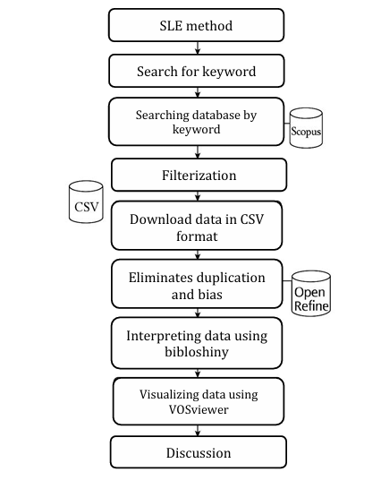
Figure 1. Research Method Flow Diagram
Prism Method
The prism method is used to carry out the following data screening process, which is the step used in the method in figure 2:
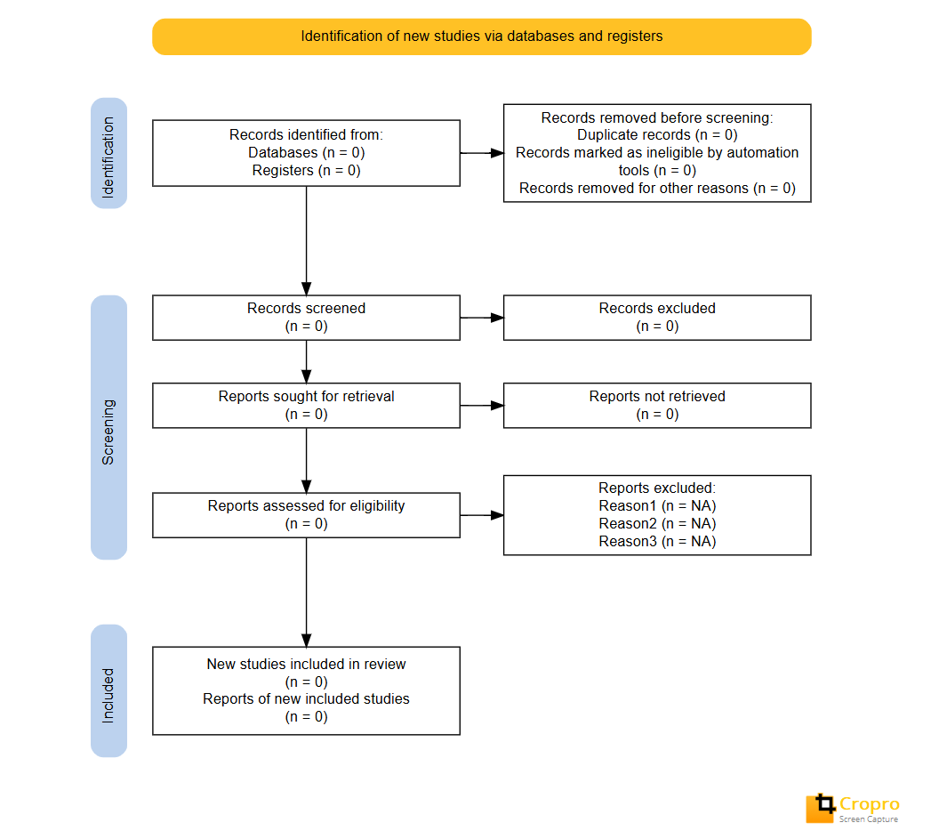
Figure 2. Prisma Systematic Literature Review Method
In table 2 above, the process of selecting articles in this systematic review is carried out with reference to the PRISMA (Preferred Reporting Items for Systematic Reviews and Meta-Analyses) guidelines and is described in detail through the flow diagram in the PRISMA Figure above This process consists of four main stages, namely identification, screening, eligibility, and inclusion.

RESULTS AND DISCUSSION
Bibiometric Studies

In the bibliometric analysis, the search strategy used used Scopus data sources related to this research theme. From several keywords selected, 3 keywords were chosen, namely keywords for a broad search about AI in grading, focusing on the benefits and biases of AI in grading and keywords to highlight the validity and reliability of AI in academic assessment.
For a broad search on AI in grading

("Artificial Intelligence" OR "AI" OR "Machine Learning")

AND
("Automated Grading" OR "Automated Assessment" OR "AI Grading" OR "Automated Scoring")
The data obtained is 349 from 1997-2025 and after a filter was carried out which included Articles with limitations, Open Access, 2015-2025, English, Type (Articles, Review, Procesing Conference) in 110 articles was obtained
To focus on the benefits and biases of AI in assessment
("Artificial Intelligence" OR "AI" OR "Machine Learning")
AND
("Automated Grading" OR "AI Grading" OR "Automated Assessment")
AND ("Bias" OR "Fairness" OR "Equity" OR "Ethical Issues")
The data obtained are 2 articles that are limited to the years 2015-2025
To highlight the validity and reliability of AI in academic assessment
("Artificial Intelligence" OR "AI" OR "Machine Learning")
AND ("Educational Assessment" OR "Assessment System" OR "Automated Grading")
AND ("Validity" OR "Reliability" OR "Transparency")
The initial data obtained was 15 from 1997-2025, but after filtering with the same criteria, data was obtained with a total of 14 articles from 2015-2025.
From the above data, it is exported to CSV, then CSV is inserted into the Open refine data to filter out duplicate data. From the total searches above, 110+2+14=126 articles.
Reduce duplicate data
With the use of data from the 3 files of the search results of the keywords above that are exported, it is compressed zip and then entered into open refine. This application is used to filter data especially to see whether or not the data obtained from search results is there (Pranckutė, 2021). In addition, this application can also be used to eliminate keyword bias contained in the data obtained where initially the data was obtained as many as 128 articles, when entered into open refine to 121 articles.
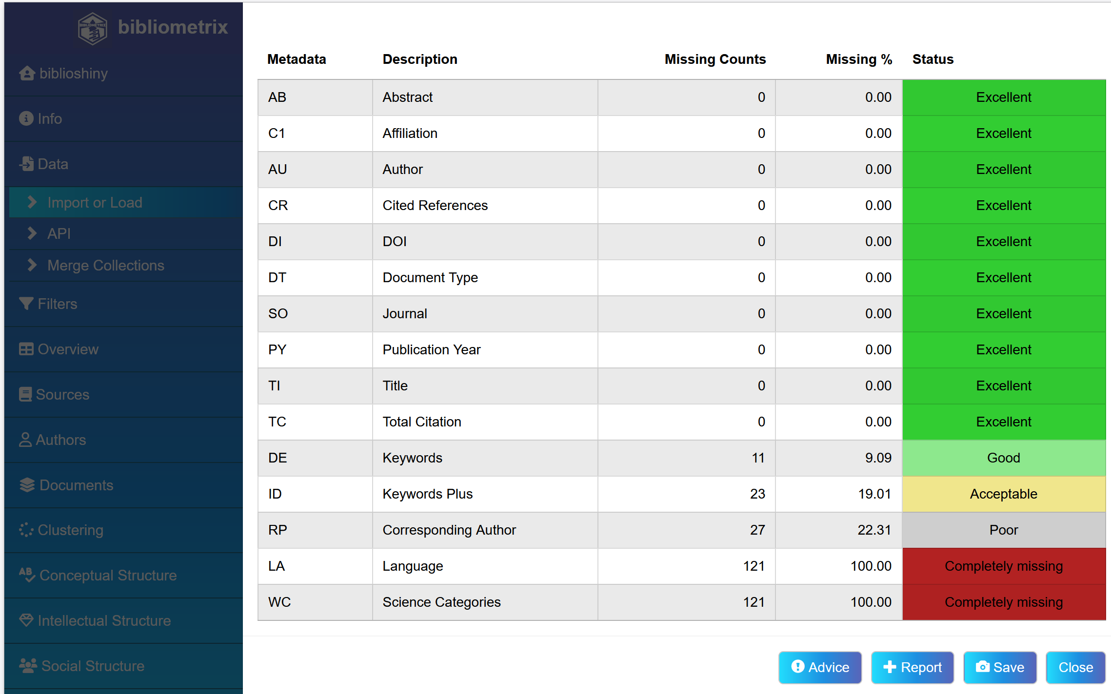
Figure 3. The meta data on DE/Keword is good
Furthermore, the process of interpreting bilometric data can be carried out using the Bibliosiny application as follows. Data The main information as a whole is obtained is seen in the picture.
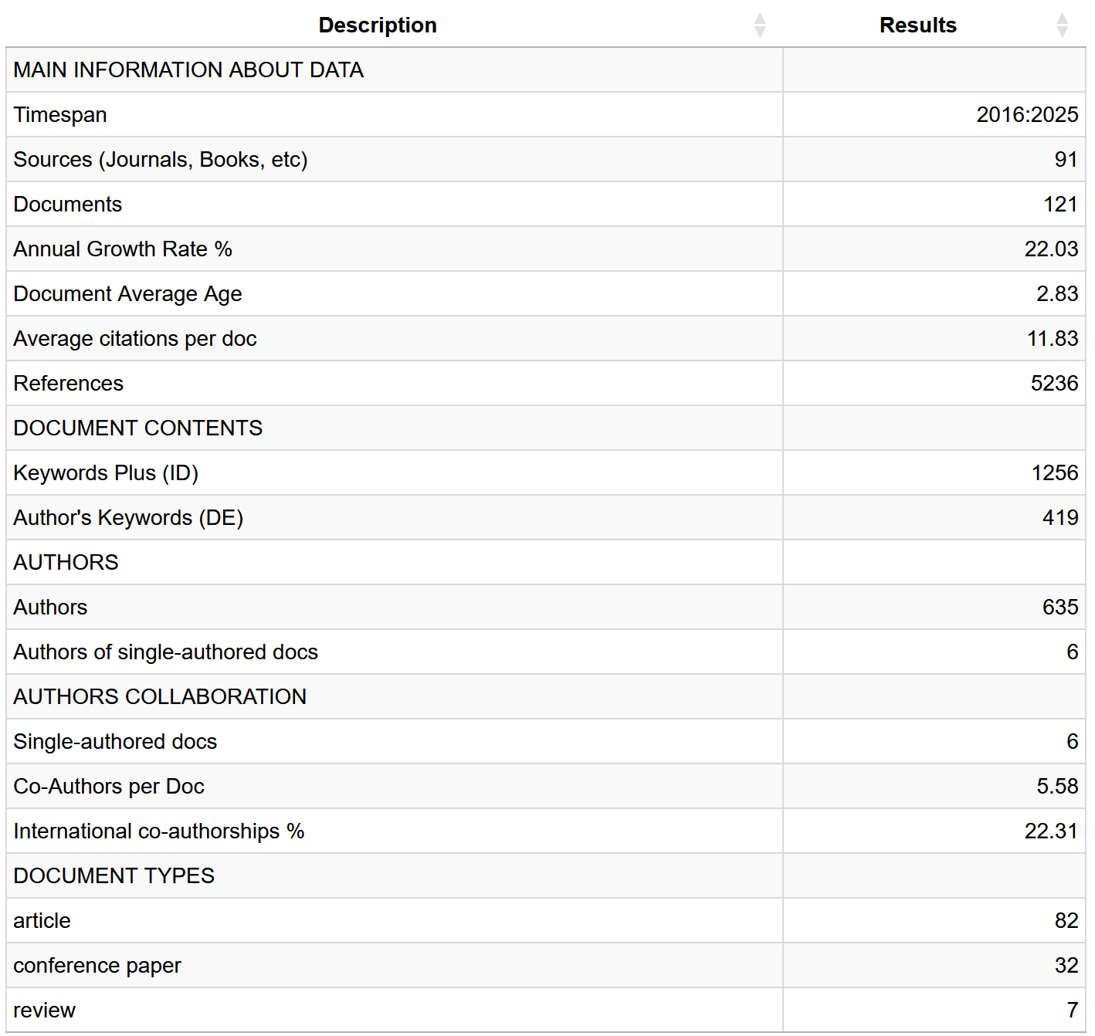
Figure 4. Main information on the data sheet
The image displays a table that summarizes key information from the research data from 2016 to 2025. In this period, it was recorded that there were 121 documents used, coming from 91 different sources such as journals, books, and others. The annual growth rate of publications reaches 22.03%, which means that there is a fairly rapid increase from year to year. The average age of documents is around 2.8 years, which indicates that most documents are still relatively new. Interestingly, each document gets an average of about 12 citations, indicating that the results of this research are quite influential in their field. The total references used in the entire document reached 5,236, indicating that each document referred to multiple sources and had a solid foundation.
In terms of content, it found about 1,256 "Plus" keywords (which are usually added by the system to expand the topic), and 419 keywords that came directly from the author. This shows that the scope of the research topic is quite broad, but there is still a specific focus according to the author's interests. Regarding collaborations, there are 635 authors involved in the overall publication. Only 6 documents were written by one person, so it can be concluded that collaboration is common in this study. On average, there are 5 to 6 authors in one document. In addition, about 22% of the publications involved cooperation between countries, which indicates international involvement in the development of this research.
When viewed from the type of documents, most of them are in the form of articles (82 documents), followed by conference papers (32), and the rest in the form of literature reviews (7). This shows that research results are more published in the form of scientific articles and conference presentations than in literature reviews. Overall, these data illustrate that over the past almost decade, publications in this field have been evolving, largely collaborative, have a wide range of topic coverage, and have had considerable impact in the scientific community. The graph below the table provides a visual overview of how these publication trends have evolved from year to year.

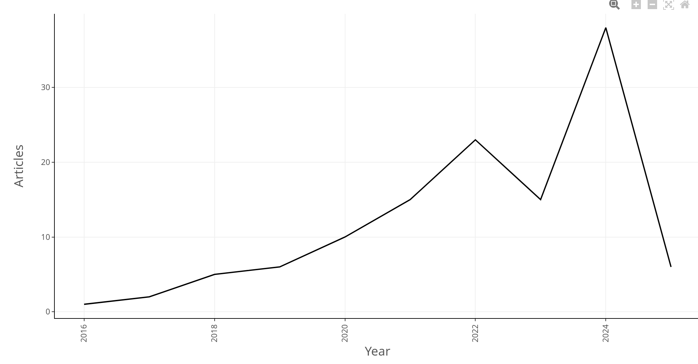
Figure 5. Year-over-year growth chart.
It can be shown by the distribution of the data table as below.
Table 1. Yearly growth.
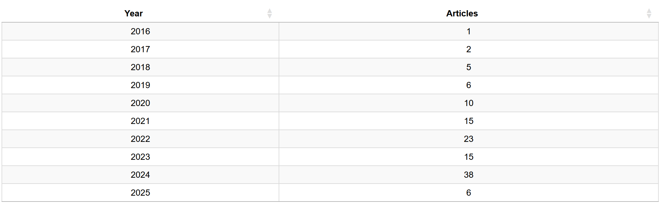
Based on the graph and table 1 above shown, we can see an increasing trend in the number of scientific publications from year to year. At the beginning of the period, precisely in 2016, the number of articles published was still very small, only one or two. But from 2017 to 2021, it can be seen that there is a steady growth every year, the number of publications continues to increase slowly. The peak occurred in 2022, where the number of articles jumped sharply to more than 30 publications. This was the most productive year during that period. But after that, in 2023 and 2024, the chart shows a fairly significant decline. The number of articles published has dropped quite drastically compared to the previous year.
From this pattern, we can conclude that there was an explosion of research activity in 202. Maybe because of greater support, increased funding, or research focus that was indeed high at that time. While the decline in the following years could be due to reduced resources, a shift in research focus, or other external factors that influence. Even so, in general, the trend that looks positive remains positive. The production of scientific articles tends to increase when viewed in the overall time span, and this indicates good progress in research activities in the field.

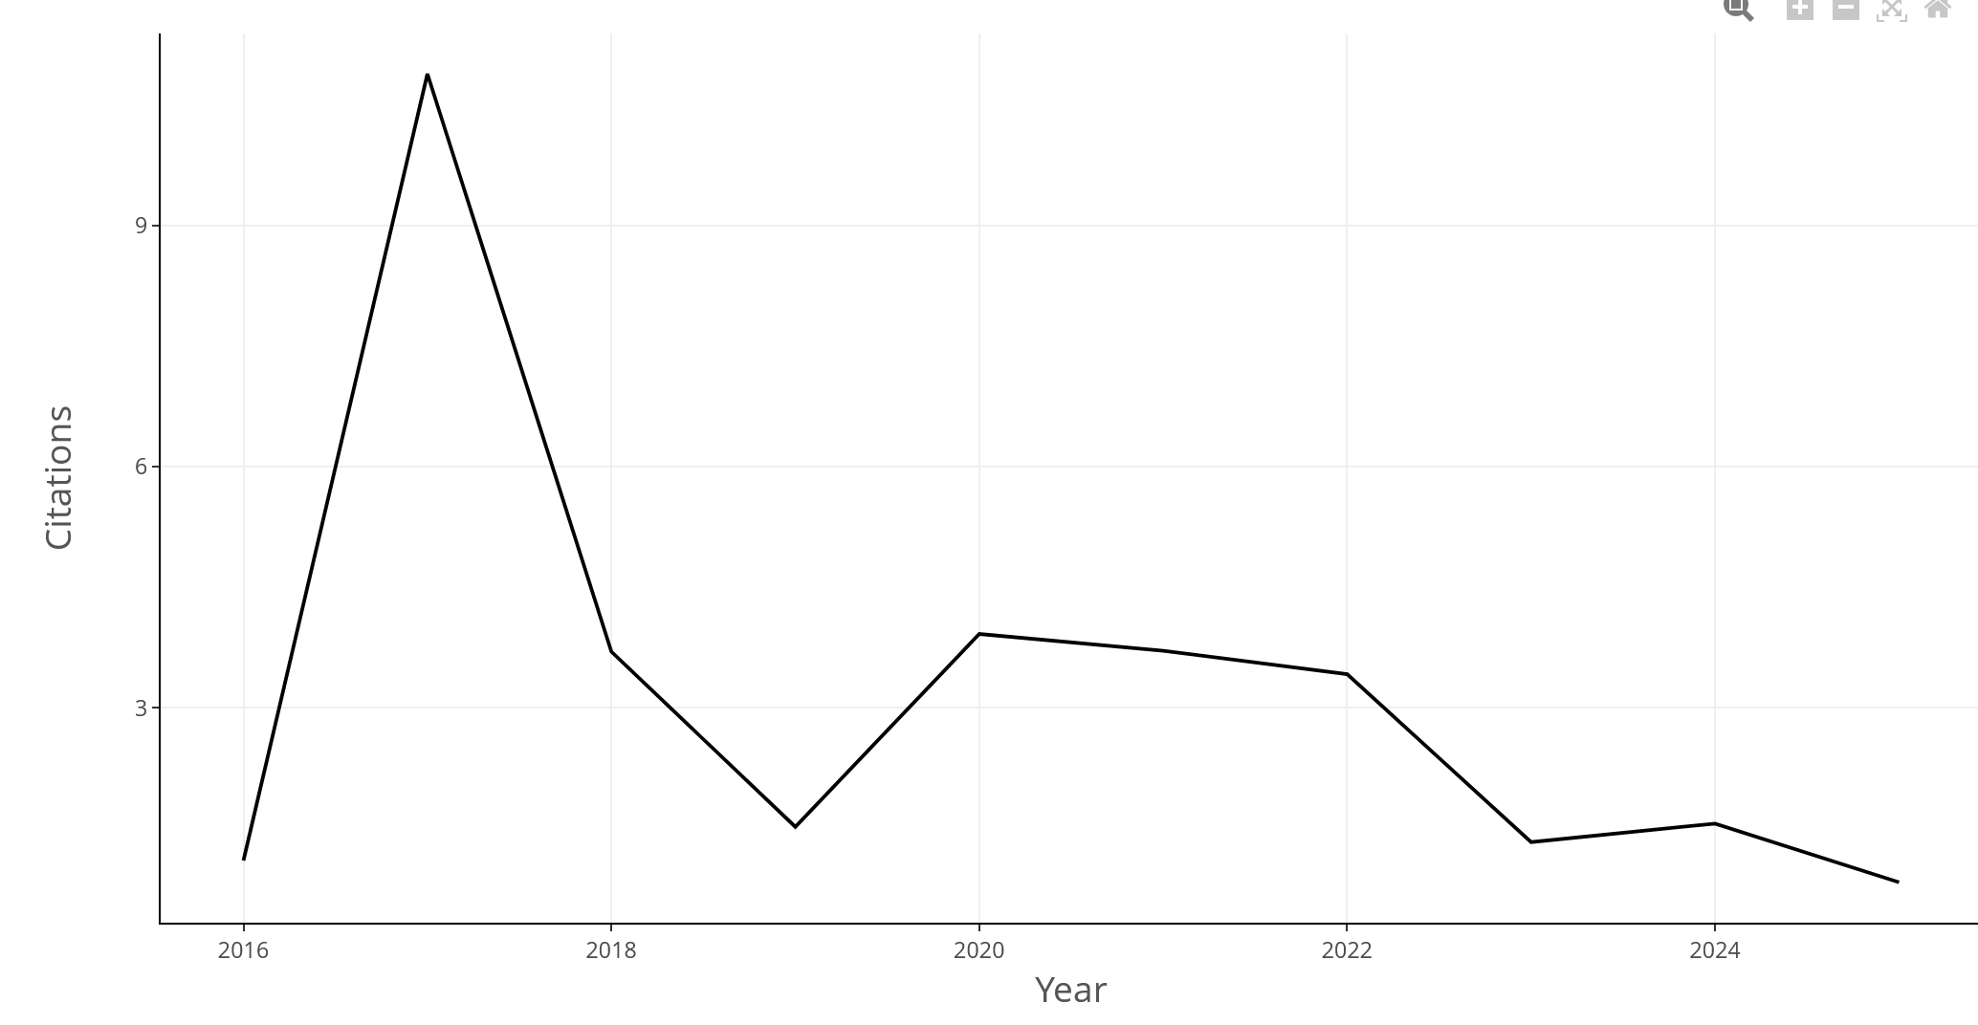
Figure 6. Annual Citation Chart
It can be explained in the form of a table distribution as below.
Table 2. Annual Citation
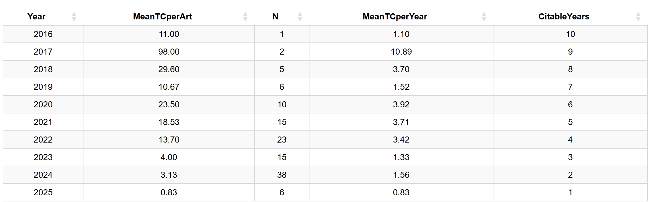
Figure 6 The graph and table 2 shown provide an overview of the production of scientific articles each year, by looking at several important aspects, such as the average citations per article (MeanTCperArt), the number of articles published (N), the average citations per year (MeanTCperYear), and the number of years the article can be cited (CitableYears).
In 2016, there was only one article published, but interestingly the article had a considerable impact with an average of 11 citations. After that, the number of articles began to increase by two articles in 2017 and five articles in 2018. However, although the number of articles increased, the average citations actually decreased, for example to around 10.89 in 2017 and dropped further to 3.70 in 2018.
A jump in the number of articles was also seen in the following years, such as in 2020 and especially in 2021, which recorded 15 articles with an average of citations per year of around 3.71. But the most striking is from 2022 to 2024, when the number of articles rose sharply by 23 articles in 2022 and reached 38 articles in 2024. Unfortunately, this increase in number is not accompanied by a commensurate impact of citations. For example, in 2024, even though many articles are published, the average citation will actually drop to 1.56 per article.
The year 2025 also shows a similar thing. There were only 6 articles published, and the average citation was even lower, which was 0.83. This may be because the articles are still new, so they haven't been cited much. Overall, this data shows that although productivity in writing articles increases from year to year, not all of them have a high impact in terms of citations.
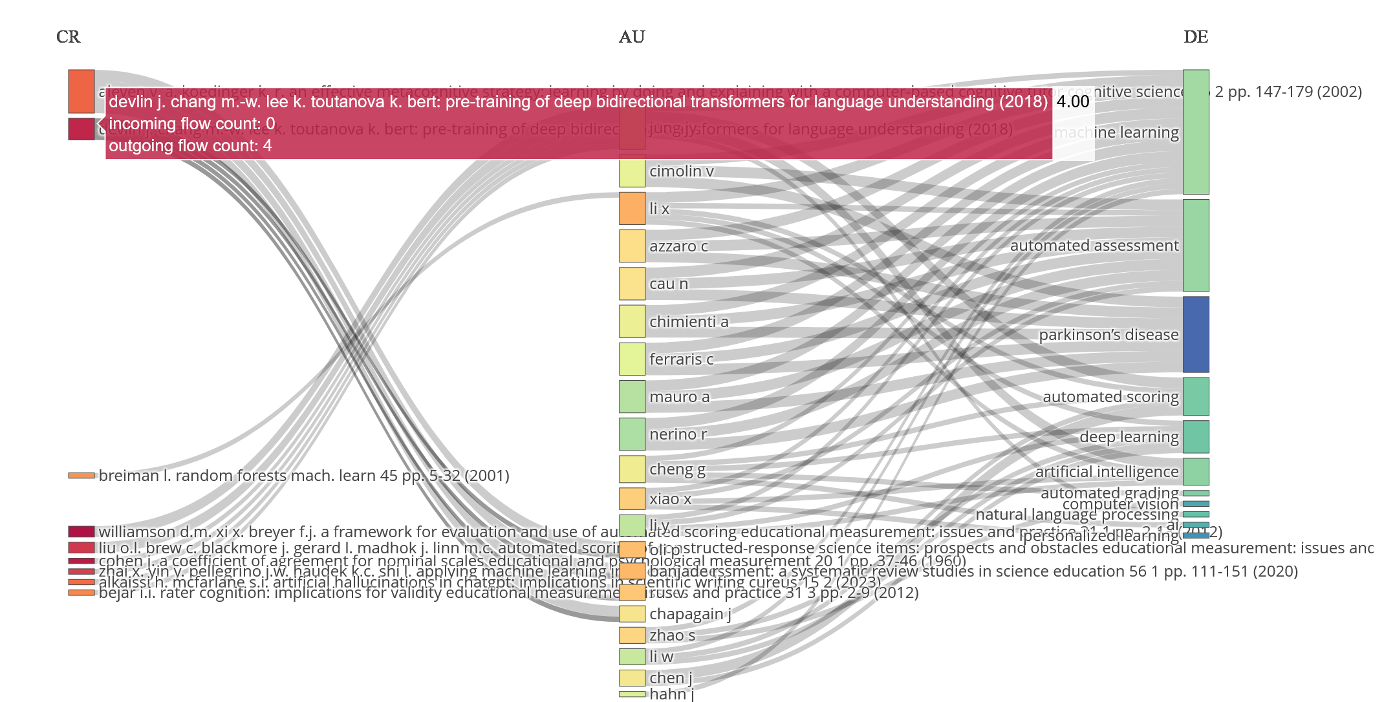
Figure 7. Three-Field Plot diagram
Figure 7 above shows a Three-Field Plot diagram, which illustrates the relationship between three important elements of research: frequently cited scientific references (CR), author names (AU), and research topics or themes discussed (DE). This diagram helps us see how the three are interconnected, who wrote what, and where they referred.
In the reference section (CR), there are two names that stand out the most because they are most often cited, namely Aleven V. and Koedinger K. R. with their work on metacognitive strategies in computer-based learning, as well as Devlin J. and his team who are famous for the BERT model, which is a preliminary training method for transformers in language processing. These two references are the main references for many studies in this field.
If we look at the author section (AU), some of the names that often appear are Cimolin V., Li X., Azzaro C., and Chimenti A. They are known to be active in writing in topics such as machine learning, automatic assessment, and deep learning. This means that they contribute a lot to research involving advanced technologies in the world of education and data analysis.
Meanwhile, in the topic (DE) section, themes that often appear include machine learning, automated assessment, deep learning, and artificial intelligence (AI). This shows that the authors are indeed focused on the use of modern technology in education ranging from automatic assessment to natural language processing using AI.
Overall, this diagram shows the close relationship between the authors, the references they use, and the topics they raise. They are all interconnected in one common thread: the application of smart technology to support the learning and evaluation process in education.
For the most relevant sources in can be as shown in figure 8 below.
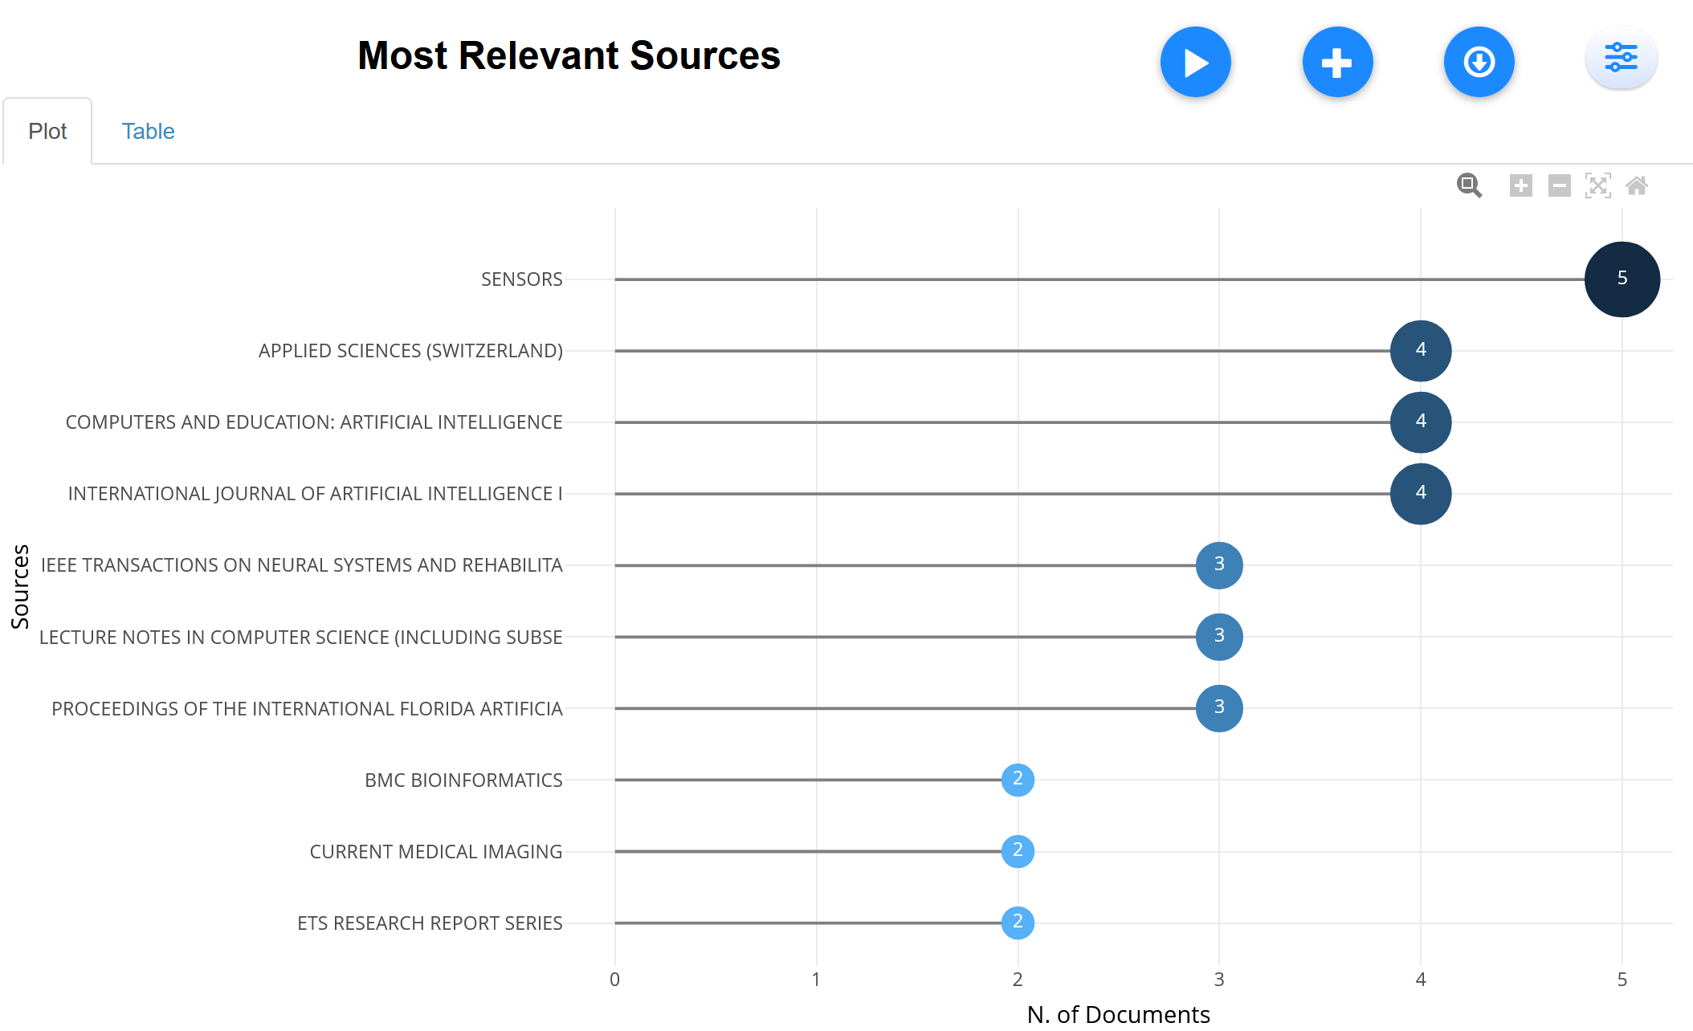
Figure 8. Most relevant Source
From the data shown in figure 8, the journal SENSORS was recorded as the most published articles in this study, with a total of 5 documents. This shows that the journal has an important role in the development of the topics discussed. The other three journals that are also quite prominent are Applied Sciences (Switzerland), Computers and Education: Artificial Intelligence, and the International Journal of Artificial Intelligence I—each contributing 4 documents, which signifies their significant contributions in the related field.
In addition, there are several other journals such as IEEE Transactions on Neural Systems and Rehabilitation Engineering, Lecture Notes in Computer Science (including subseries), and Proceedings of the International Florida Artificial Intelligence Research Society, which publish 3 papers each. Although the number is slightly lower, these journals still have a fairly important role.
Several other journals such as BMC Bioinformatics, Current Medical Imaging, and ETS Research Report Series only contributed 2 articles each. This shows that while they are still relevant, their contributions are not as large as the major journals mentioned earlier.
Overall, this data gives an idea of the most influential journals or sources of publications in this study. The journal SENSORS and several other journals appear to dominate, which shows that the research topics are closely related to sensor technology, artificial intelligence in education, and computer science. However, the diversity of sources also shows that this field of research touches a wide range of disciplines—from engineering, education, to medicine and bioinformatics.

Table 3. Sources' Local Impact
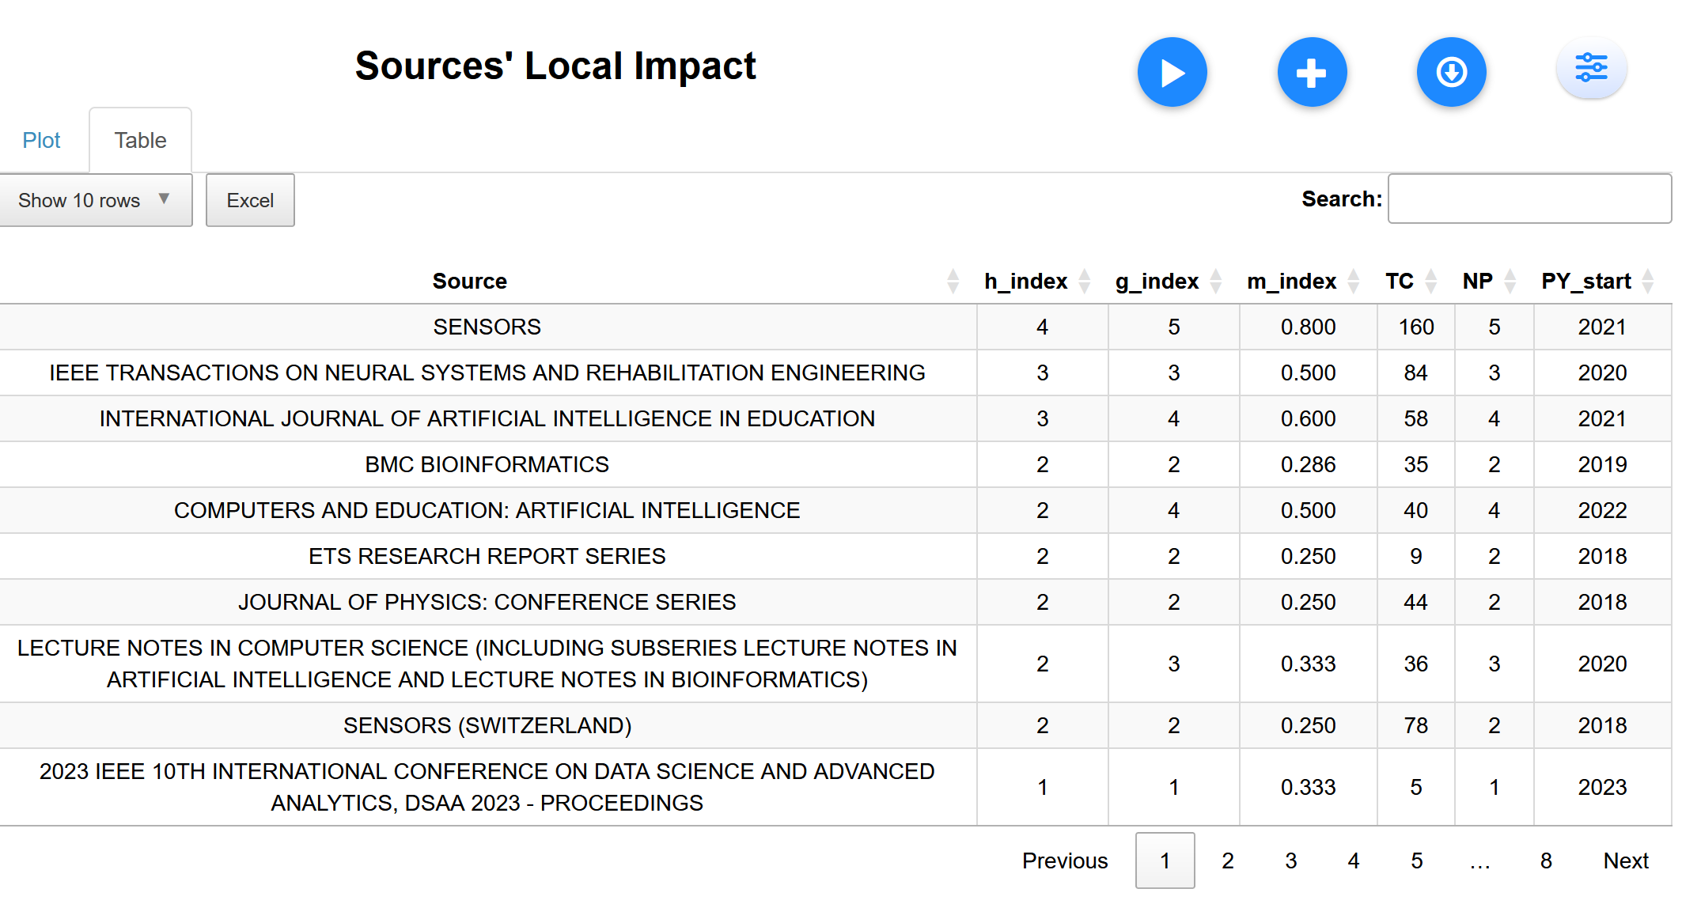
Based on the data from Table 3 above, it can be seen that the SENSORS journal occupies the top position as the source with the most influence. This can be seen from the highest h-index value (4), the highest g-index (5), the m-index value of 0.800, and the highest total number of citations (TC) which is 160 since it began to be published in 2021. This means that articles from these journals quickly gain attention and are recognized in the scientific community. The journal IEEE Transactions on Neural Systems and Rehabilitation Engineering also shows a strong influence, with an h-index of 3, a g-index of 3, an m-index of 0.500, and a total of 84 citations since 2020. This makes it one of the most influential sources, especially in the field of engineering and rehabilitation.
Meanwhile, the International Journal of Artificial Intelligence in Education recorded an h-index of 3, g-index 4, and an m-index of 0.600, which indicates that this journal is quite influential in research on artificial intelligence in the world of education since 2021. Several other journals such as BMC Bioinformatics, Computers and Education: Artificial Intelligence, and ETS Research Report Series have an h-index of 2. Although the numbers are not as high as previous journals, they are still relevant and contribute to scientific discussions, particularly in their respective fields.
There are also journals or proceedings such as Sensors (Switzerland) and the Journal of Physics: Conference Series which both have an h-index of 2, but with a number of publications and citations that are not as many as other top journals. The most recent source, the 2023 IEEE 10th International Conference on Data Science and Advanced Analytics (DSAA 2023 – Proceedings), is recorded with an h-index and g-index of 1 each, an m-index of 0.333, and a total of 5 citations. This shows that the conference is still in its early stages to build its impact in the scientific community. Overall, this data shows a variation in the level of influence between journals. SENSORS and IEEE Transactions on Neural Systems and Rehabilitation Engineering stand out as the most influential publications, while the others remain important contributions in their respective fields, albeit on a smaller scale.
Next is the Core Sources by Bradford'd Law data. This data is taken from the top 10 data.
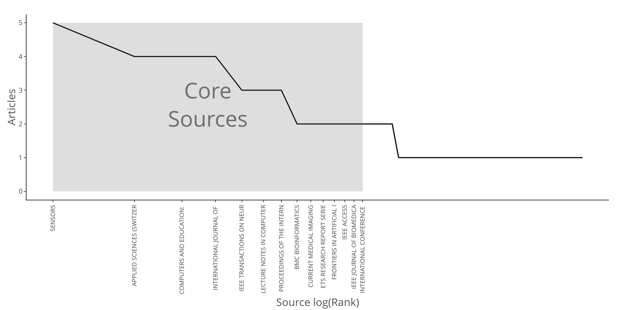
Figure 9. Core Sources by Bradford'd Law

Figure 9 shows the distribution of the main sources of scientific publications under Bradford's Law. This graph shows how scientific articles are scattered across various journals or sources, following a pattern called Bradford's Law of Scattering. In this graph, the horizontal axis depicts the order of sources based on logarithmic rank (log(Rank)), and the vertical axis shows the number of articles published by each source.
According to Bradford's principle, only a small number of core journals produce the majority of articles on a topic, while most other journals contribute only a small number of articles. This pattern is clearly visible on the chart. For example, the journal SENSORS is the most prominent because it publishes 5 articles, followed by several other journals such as Applied Sciences (Switzerland), Computers and Education, International Journal of Artificial Intelligence, and IEEE Transactions on Neural Systems and Rehabilitation Engineering, which publish 4 articles each.
The journals mentioned above fall into the category of "core sources" marked on the graph with gray areas. After passing through this core group, it can be seen that the number of articles from subsequent sources decreases drastically, generally only publishing 3 articles or even fewer.
Overall, this graph shows that most scientific publications are concentrated in a few major journals, while the rest only contribute small amounts. This is in accordance with the concept of Bradford's Law which describes that research activities in a field are usually focused on a few highly productive sources.
Next is the Cumulate Occurrences graph data.
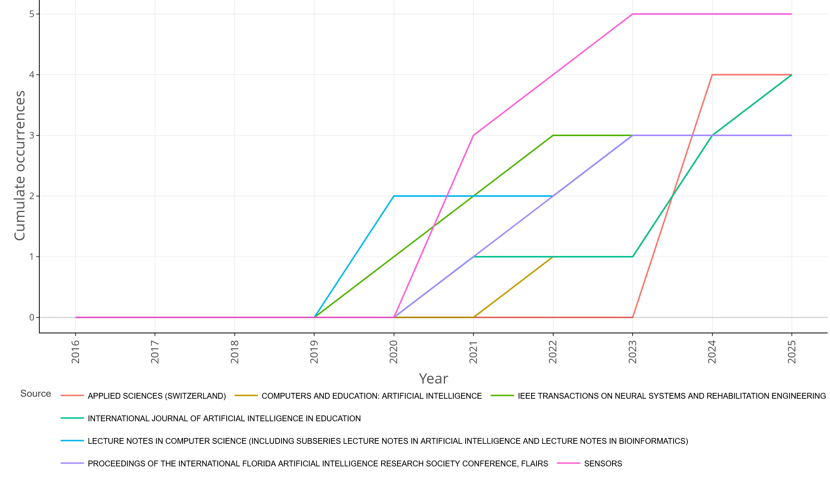
Figure 10. Cumulate Occurrences
Figure 10 shows a cumulative graph of publications from various journals and conferences between 2016 and 2025. Each colored line on the graph represents one different source of publication, and shows how the number of articles from each source has increased over time. From the graph, it can be seen that the SENSORS journal (marked with a purple line) is the most prominent. Publications from this journal have been consistent since 2019 and experienced a sharp increase in 2023 and 2024, then reached a peak in 2025. This shows that SENSORS is increasingly being used as a reference and is becoming one of the main sources in this field.
The IEEE Journal Transactions on Neural Systems and Rehabilitation Engineering (green) also shows steady growth since it became active in 2020. Meanwhile, the International Journal of Artificial Intelligence in Education (in blue) began to see an increase in publications in the same year, although the growth was not as fast as IEEE Transactions.
Lecture Notes in Computer Science (turquoise) also became active in 2020, but its growth slowed after a few years, indicating that while it is still relevant, its contribution is not as much as other sources. Meanwhile, the other two sources Computers and Education: Artificial Intelligence (orange) and FLAIRS Conference Proceedings (yellow) show slower and less active publication growth in 2023 and 2024.
Overall, this graph shows that SENSORS and IEEE Transactions are two of the most active and fast-growing sources in recent years, while other sources have grown more slowly or inconsistently.
Authors Information
For Most Relevant Authors data. It can be seen in the table below.
Table 4. Most Relevant Authors
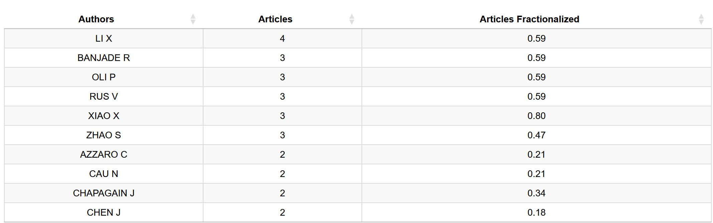
Table 4 above shows the list of the most active authors in the publications analyzed. There are two main pieces of information shown: the total number of articles written by each author, and fractionalized contributions, which is a measure of how much of their role in each article is, especially when writing with other authors. From this data, it can be seen that LI X is the author with the highest number of articles, namely 4 articles, and has a fractionalization contribution of 0.59. This figure shows that despite working with other authors, his contribution to each article is still quite large.
Authors such as BANJADE R, OLI P, RUS V, and XIAO X also wrote 3 articles each, with the same fractionalization value, which is 0.59. Meanwhile, ZHAO S also wrote 3 articles, but the fractionalized value was slightly lower at 0.47, indicating a collaborative role that may be more divided than other writers. There are also several authors such as AZZARO C, CAU N, CHAPAGAIN J, and CHEN J, who have written 2 articles each. However, their contributions per article vary between 0.18 to 0.34, which suggests that they are most likely to write alongside a larger team.
Overall, these data show that although some authors are quite productive in the number of articles, the level of their individual contributions in each article tends to be moderate or evenly split with other co-authors.
Data authors Production over Time.
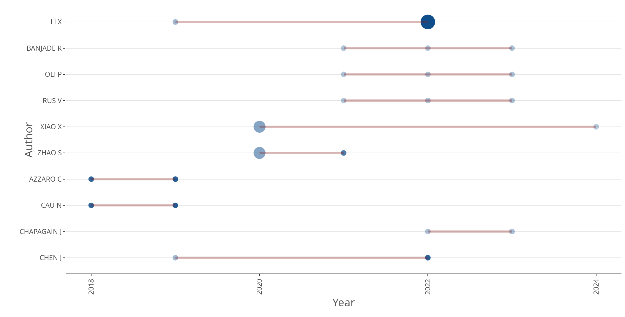
Figure 11. Copyright © 2019 Copyright © 2019
Figure 11 above shows a graph showing the productivity of writers from 2018 to 2024, showing how many articles they produce each year. Each line in the graph represents a single author, where the length and thickness of the lines reflect the number of articles and the time period of publication. From this graph it is clear that LI X is the most prolific writer, with a large number of articles especially in 2020 and 2021, and still continues to contribute until 2022. Meanwhile, authors such as BANJADE R, OLI P, and RUS V are also quite active, although the number of articles is not as much as LI X. They seem to be consistent in publishing works, especially around 2020 and 2021.
Other authors such as XIAO X and ZHAO S are also quite actively involved, albeit with a slightly lower number of publications. Meanwhile, AZZARO C and CAU N appear to have had a smaller number of publications, but they remained active in publishing articles periodically throughout the period. On the other hand, the contributions of CHAPAGAIN J and CHEN J appear to be more limited. CHAPAGAIN J had several publications in 2020, while CHEN J was only recorded to have published one article in 2023.
Overall, this graph provides a clear picture of who are the most active authors in this field of research. LI X seems to be the most prominent, while the other authors continue to show important roles despite the smaller number of publications.
Countries
The following is the Author's Coreesponding by country.
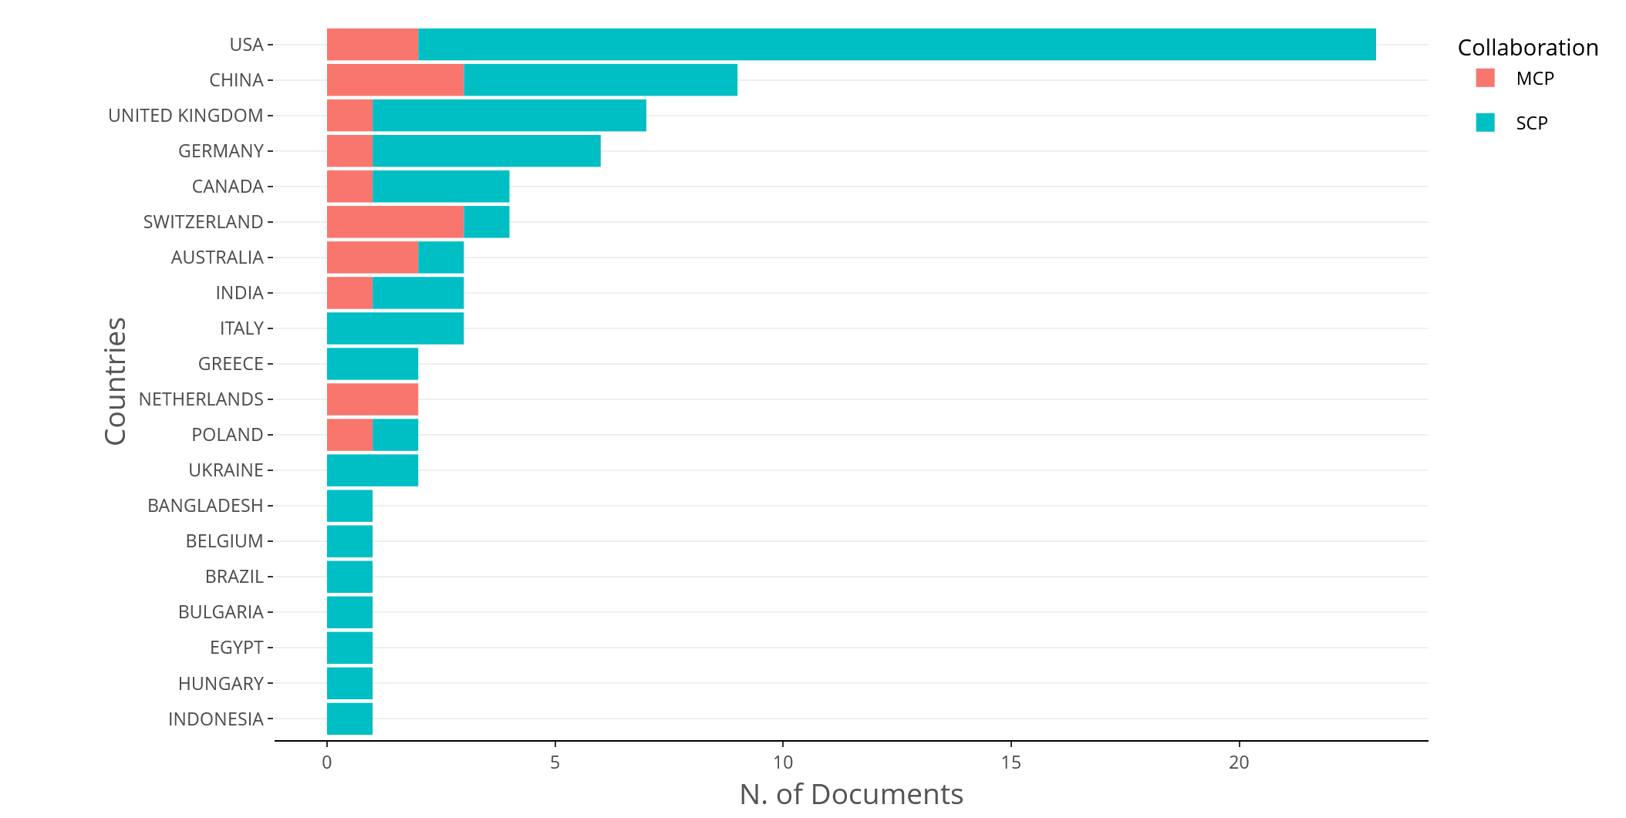
Figure 12. Author's Coreesponding by country.
Figure 12 above shows a graph showing the number of scientific papers published by the country of origin of the author of the correspondence. This graph divides the types of collaboration in publications into two: SCP (Single-Country Papers) which means that authors are from only one country (marked in green), and MCP (Multi-Country Papers) which means that authors work together across countries (marked in red). From the graph, it can be seen that the United States (USA) is the country with the highest number of publications, and most of its articles are written by authors from the country itself (SCP). China also occupies the top position, with a fairly balanced distribution between national publications and international collaborations.
Countries such as the United Kingdom and Germany follow with a high number of publications, and most of them also come from domestic collaborations (SCPs). Then, countries such as Canada, Switzerland, Australia, and India also showed a considerable number of publications, although the majority were still in the SCP category. Meanwhile, countries such as Italy, Greece, the Netherlands, and Poland have smaller contributions, but remain active, especially in the category of domestic publications. Other countries such as Bangladesh, Belgium, Brazil, Bulgaria, Egypt, Hungary, and Indonesia were also recorded as contributing, although the number of documents was smaller and most of them were included in the SCP.
In general, this graph shows that scientific publications in this field are dominated by large countries such as the USA and China. Even so, there are also many contributions from various other countries, both through international cooperation and independent publications at the national level.
The following is the data of the top 10 Countries' Scientific Production.
Table 5 top 10 Countries' Scientific Production.
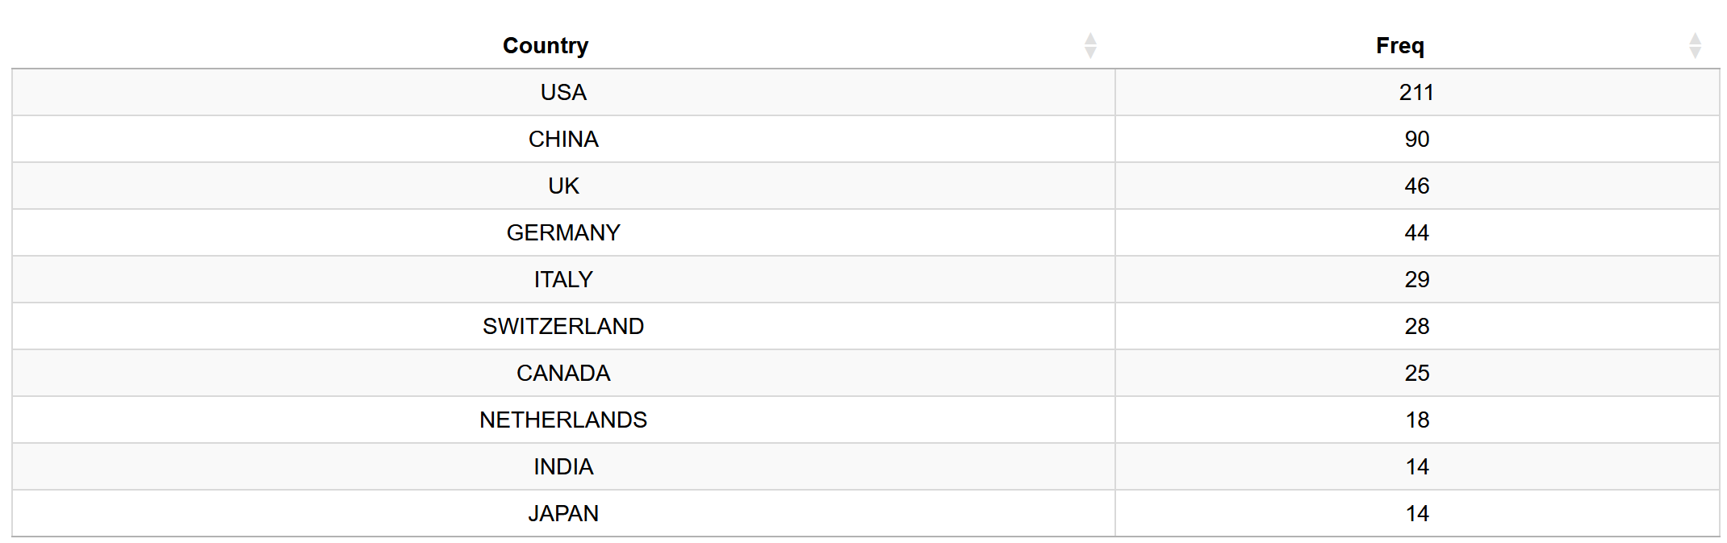
Table 5 above shows the number of scientific publications produced by each country from 2016 to 2025. From the data, the United States (USA) is in the top position with 211 documents, showing how much they contributed to research during this period. China ranks second with 90 documents, quite large as well, although still far behind the USA. Next in order, there is the UK with 46 publications, followed by Germany which recorded 44 documents, both of which continue to show a strong role in the development of global science. Italy and Switzerland are also on the list with 29 and 28 papers, which means they are quite active in their scientific contributions, although the scale is not as large as the countries above.
Canada and the Netherlands recorded 25 and 18 publications, respectively, while India and Japan followed with 14 documents per country. Although the number is smaller, the contributions of these countries remain significant in the international research arena. Overall, this data shows a gap in the number of publications between countries with the USA and China as major players, while other countries continue to play a role, albeit on a smaller scale.
Countries' Production over Time
The following is the data on Countries' Production over Time. The data can be seen in the graph below.
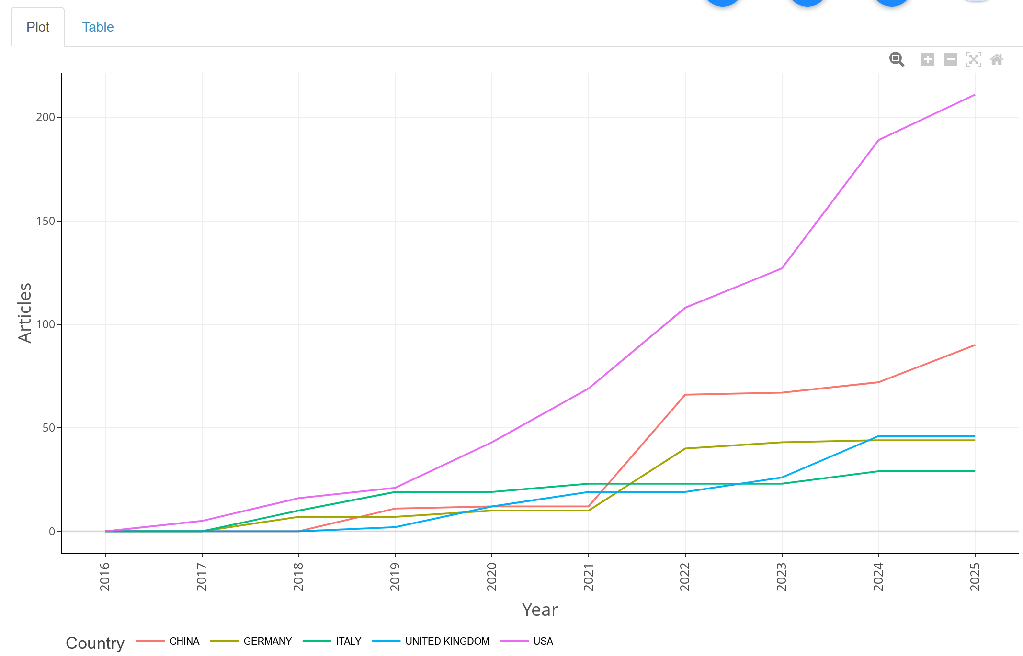
Figure 13. Charts of Countries' Production over Time
Figure 13 above shows how the trend of scientific publications is developing in several countries, namely China, Germany, Italy, the United Kingdom (UK), and the United States (USA). from 2016 to 2025. In this graph, each line represents one country, with the horizontal axis indicating the year and the vertical axis indicating the number of articles published. From the chart, the USA (with the purple line) looks the most prominent. After 2020, the number of publications from this country jumped sharply and continues to increase until 2025. This shows how dominant the USA's role is in the world of research today. China (red line) also showed rapid growth that began to be felt since 2020, with a trend that also continued to climb until the end of the period.
Meanwhile, Germany (green line) experienced a slower increase, but still showed steady growth. Italy (blue line) and the UK (yellow line) have a trend that tends to be flat with no major spikes, but still increase consistently from year to year. Overall, this graph shows that the USA and China are major players in the production of scientific articles, with very noticeable growth, especially in recent years. European countries such as Germany, Italy, and the UK are also actively contributing, albeit at a slower growth rate.
Most Cited Countries
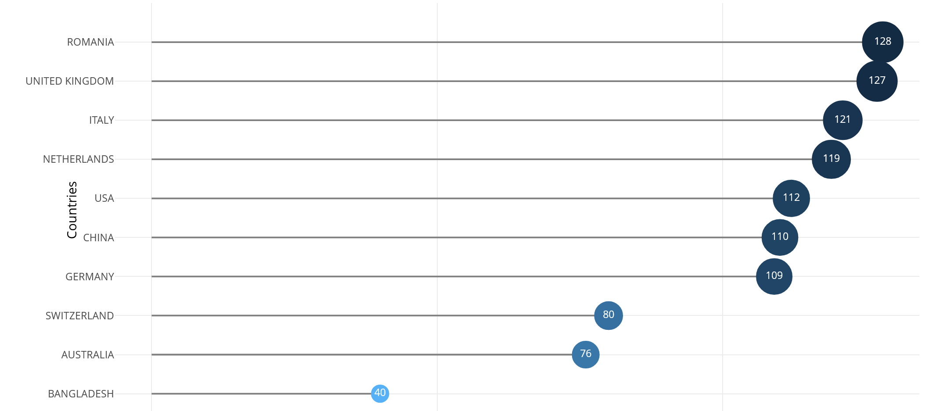
Figure 14. Most Cited Countries
Figure 14 above shows a graph showing the countries with the highest number of citations in the scientific publications analyzed. In this graph, the vertical axis shows the name of the country, while the horizontal axis shows the total citations received by publications from each country.
From the graph, it can be seen that Romania is in first place with 128 citations, followed by the United Kingdom with 127 citations, and Italy with 121 citations. This shows that these countries have a considerable impact in this field of scientific publication. Furthermore, the Netherlands was recorded with 119 citations, while the USA and China received 112 and 110 citations, respectively. Although the USA and China have a larger number of articles, they are not as dominant in terms of the number of citations compared to other countries.
Countries such as Germany, Switzerland, Australia, and Bangladesh recorded lower citations. Germany received 80 citations, and Switzerland received 76 citations. Meanwhile, Bangladesh is in last place with only 40 citations, showing that despite contributing to scientific publications, its influence in terms of citations is still much smaller compared to other major countries.
Overall, this chart reveals that Romania, the United Kingdom, and Italy dominate in terms of citations, while although major countries like the USA and China have a lot of publications, they are not so dominant when it comes to citations.
Overlay visualization.

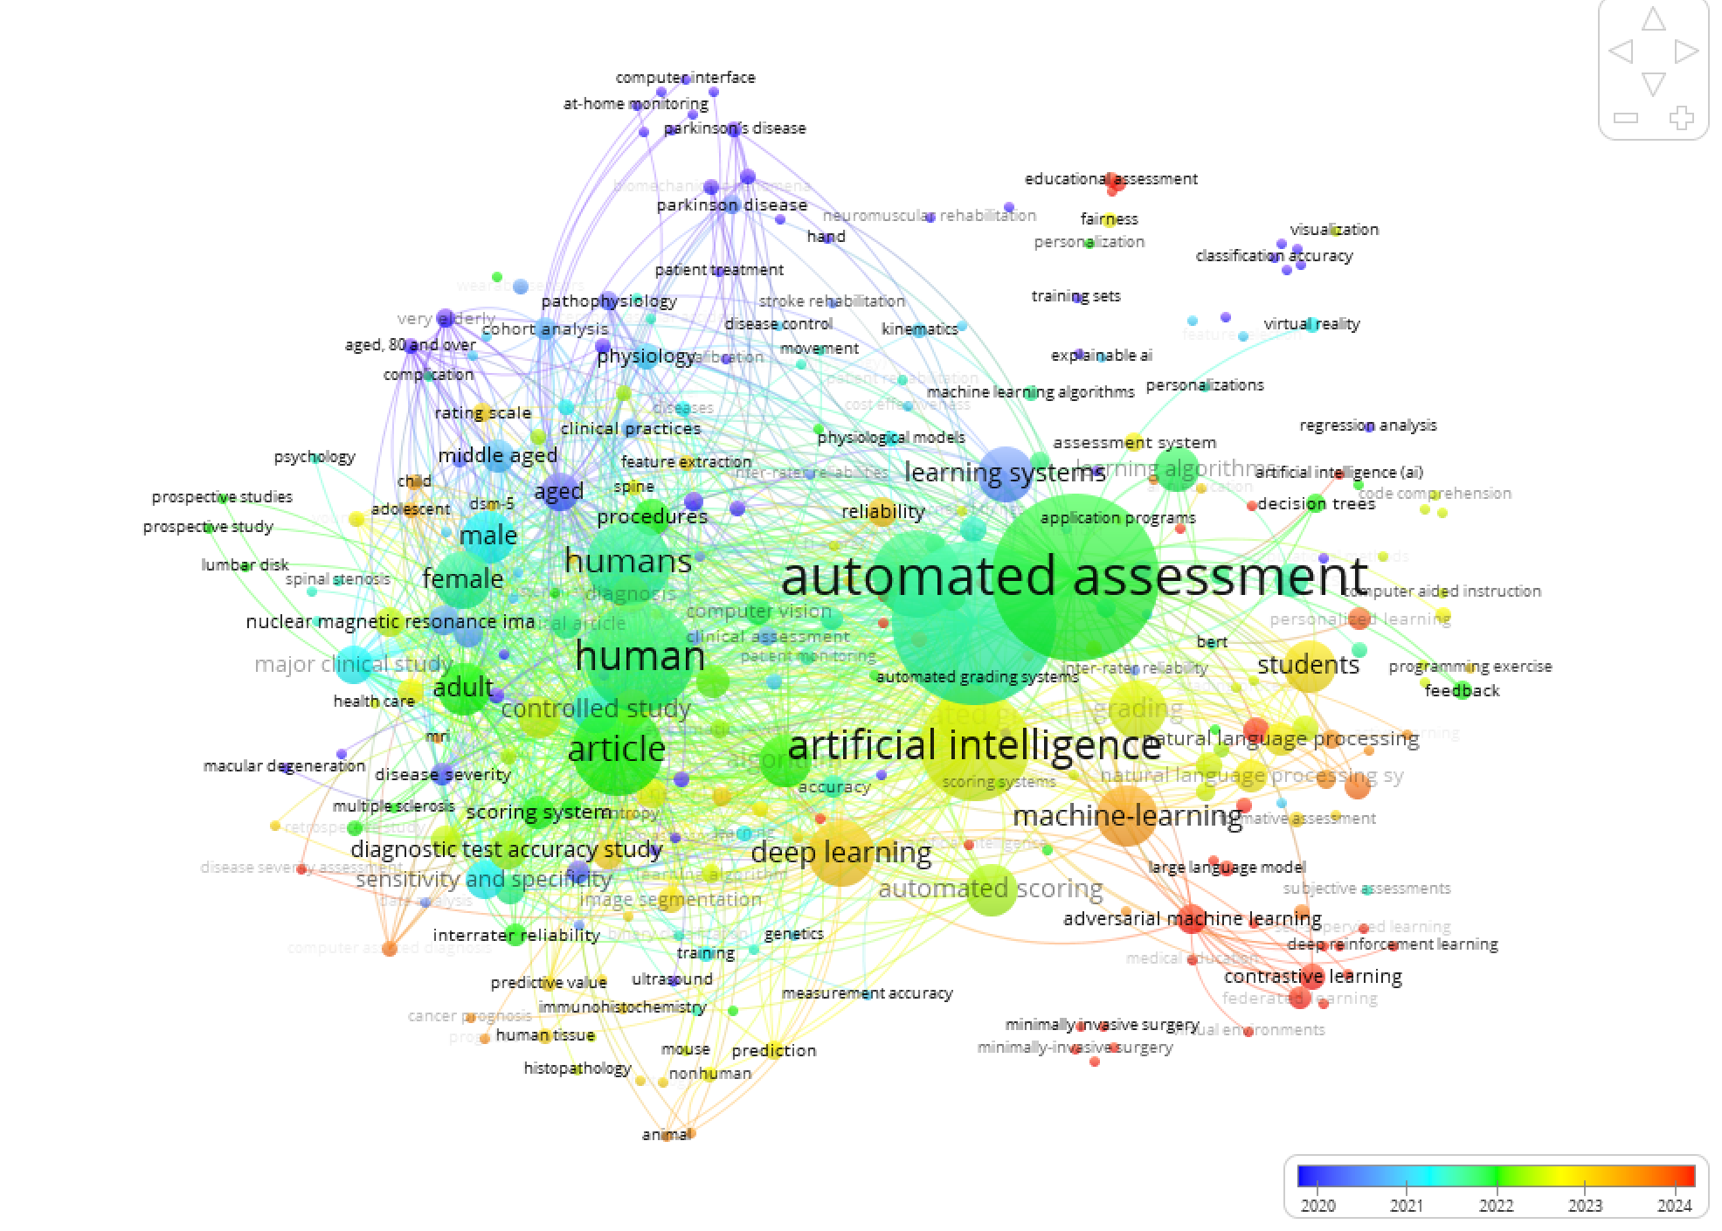
Figure 15. Contact map
Figure 15 above shows a keyword map showing the relationships between various topics related to "automated scoring," "artificial intelligence," and "machine learning" in scientific research published between 2020 and 2024. This map provides an overview of how various concepts, technologies, and topics are interconnected.
In the center of the map, it can be seen that "automated assessment" and "artificial intelligence" are the two main topics, with related keywords around them such as "machine learning", "deep learning", and "automated assessment". This suggests that the application of AI and machine learning in automated assessments is a major focus in recent research. Some keywords such as "student", "educational assessment", and "learning system" indicate that many studies focus on the use of AI to improve student assessment and learning.
Additionally, keywords such as "explainable AI" and "fairness" indicate a concern for transparency and fairness in the use of AI technology for assessment. Some of the other topics that emerged include "virtual reality", "natural language processing", and "predictive value", which suggests the incorporation of new technologies in automated assessment and AI. "Automated scoring systems" and "learning algorithms" also emerged as prominent topics, indicating the development of increasingly automated and intelligent scoring systems.
This map also shows how these topics have evolved over time. Lighter colors, which vary from 2020 to 2024, reflect increasingly popular trends. In recent years, research has increasingly focused on "contrastive learning", "adversarial machine learning", and "reinforcement learning", which describe the application of advanced methods in assessment technology and machine learning.
Network Visualization.
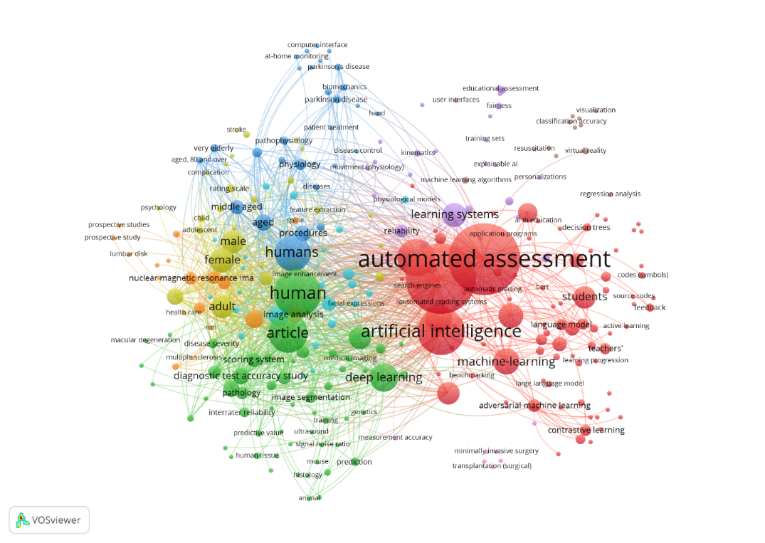
Figure 16. Network visualization
Figure 16 above is a network visualization that shows the relationship between various topics related to automated assessment and artificial intelligence (AI), especially in the context of education and medical applications. The dots in the image represent the main keywords or themes, while the lines connecting them indicate the relationships or similarities between the topics. The red group, the largest and most centralized, focuses on automated assessments and AI. Keywords such as AI, automated assessment, machine learning, and deep learning are present in this group, signifying that the main theme of this network is the application of intelligent technology in assessment, especially to support automated assessments in the fields of education and other applications.
The yellow and green groups, on the other hand, are more associated with the medical and human health worlds, with keywords such as spinal stenosis, human tissue, controlled studies, and diagnostic accuracy. This suggests that AI is also used in the fields of medical diagnostics and human health research. Words such as student, educational assessments, and training sets connected to red groups show the importance of AI in education, particularly for the assessment of student progress and the development of more personalized learning systems. Additionally, the relationship between AI, machine learning, and accuracy measurement in this image emphasizes how these technologies improve accuracy in assessments in various fields, both education and healthcare.
Overall, this visualization provides an overview of how AI and automated scoring are evolving in various fields, as well as how they are intertwined to improve efficiency and accuracy in data-driven decision-making.
SLR Study.
Of the 121 data obtained, 82 will be focused on the type of article.
Yes | Kind | Sum
1 | Article | 82
2 | Conference Paper | 32
3 | Reviews | 7
Total |  | 121

Results of the prism method
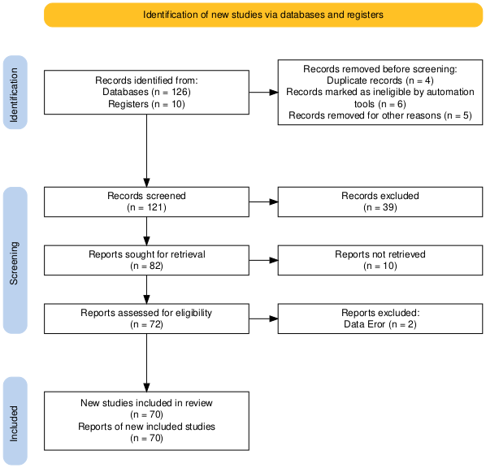
Figure 17. Results of the prism method
In Figure 17 above, the process of selecting articles in this systematic review is carried out with reference to the PRISMA (Preferred Reporting Items for Systematic Reviews and Meta-Analyses) guidelines and is described in detail through the flow chart in the PRISMA Figure above (Sohrabi et al., 2021). This process consists of four main stages, namely identification, screening, eligibility, and inclusion.
At the identification stage, the researcher obtained a total of 136 records from two main sources, namely from scientific databases as many as 126 records and from research records as many as 10 records. Furthermore, early deletion of records that do not meet the basic criteria is carried out. A total of 15 records were issued, with details of 4 records being duplicates, 6 records were deemed unsuitable by the automatic selection tool, and 5 other records were deleted for other reasons that were not specifically explained (e.g. records were incomplete or irrelevant to the topic of the study). Thus, the number of records that entered the screening stage was 121 records.
The screening stage is carried out by examining the title and abstract of each note. This process aims to identify studies that are relevant to the focus of the review. Of the total 121 records, 39 were excluded because they did not meet the inclusion criteria, such as topic mismatches, irrelevant research methods, or inappropriate population coverage. The results of this stage resulted in 82 records that were deemed worthy of full-text search.
Furthermore, at the feasibility assessment stage, a search was carried out for the complete report of the 82 records. However, as many as 10 reports were not successfully accessed, so only 72 reports could be further assessed. Each report obtained is thoroughly analyzed to ensure methodological suitability, completeness of data, and relevance to the research question. In this process, 2 reports were issued due to data errors, such as inconsistencies between results and methods, or data that could not be processed systematically.
The last stage is inclusivity, where as many as 70 studies were declared to meet the criteria and included in the final review. This number is identical to the number of reports from the study, which means that each study has one main report analyzed. This selection process shows that out of 136 initial records, only about 51.5% managed to pass to the final stage, reflecting the application of a strict selection based on objective and structured criteria. The following is a more precise classification of research methodologies based on the type of research (quantitative, experimental, observational, qualitative, conceptual, mixed and systematic review), with the number of papers and the percentage:
Table 6. Classification of types of research methods
Types of Research | Number of Papers | Percentage | Characteristics & Examples
Quantitative | 45 | 64.3% | - Using numerical data, statistical analysis, and computational models.- Examples: Research with machine learning, statistical analysis, or controlled experiments.
Experimental | 15 | 21.4% | - Controlled design with intervention or treatment.- Example: Trial of AI models on specific datasets, laboratory experiments.
Observational | 12 | 17.1% | - Observation without intervention, retrospective/prospective analysis.- Example: Clinical case study, secondary data analysis.
Qualitative | 5 | 7.1% | - Interviews, content analysis, or phenomenological studies.- Examples: Studies of user perceptions of technology.
Mixed Methods | 4 | 5.7% | - A combination of quantitative and qualitative approaches.- Examples: Surveys + interviews, or statistical analysis + case studies.
Systematic Review | 6 | 8.6% | - Synthesis of literature with a structured methodology (PRISMA).- Example: Review of AI in education.
Conceptual | 3 | 4.3% | - Theories, models, or frameworks without empirical data.- Example: A proposal for a new system architecture.
Total | 70 | 100%
In table 6, the classification of research methodologies explains that quantitative research dominates (64.3%) due to trends in the use of data, statistics, and algorithms such as machine learning. Experimental research (21.4%) is common in the medical and educational fields because it focuses on controlled trials, while observational (17.1%) is more commonly used for retrospective studies without intervention. Qualitative research (7.1%) was used to explore perceptions or behaviors, and mixed methods (5.7%) combined numerical and narrative data to gain more comprehensive insights. A systematic review (8.6%) was conducted to synthesize the literature and identify trends, while conceptual research (4.3%) was theoretical with no empirical data. Overall, quantitative dominance reflects the trends of data-driven research and AI, while other approaches remain important to social, pedagogical contexts, and theory development. The following is the classification of Main Findings based on the main findings category, the number of papers and the percentage:
Table 7. Main Findings Classification
Key Findings Categories | Number of Papers | Percentage | Specific Examples
Automated System Accuracy Improvement | 28 | 40% | CNN achieved 98.62% accuracy in osteoarthritis classification (Paper 20)
Time/Process Efficiency | 18 | 25.7% | AI reduces MRI reading time to 2.83 minutes (Paper 10)
Clinical Validation of New Tools | 15 | 21.4% | SpineNet valid for LSS assessment (Paper 35)
Workload Reduction | 12 | 17.1% | ML reduces assessment load by 64-74% (Paper 9)
Expert Equivalent Performance | 10 | 14.3% | CVSnet is 600x faster with physician-equivalent accuracy (Paper 11)
Identify New Patterns/Correlations | 8 | 11.4% | Negative correlation of task complexity with ML performance (Paper 14)
Cost Savings | 5 | 7.1% | EyeArt® is $143 cheaper per patient (Paper 37)
Improved Learning Outcomes | 5 | 7.1% | Students with AI feedback increased significantly (Paper 3)
Early/Predictive Detection | 4 | 5.7% | Cardiovascular adequacy prediction model (Paper 68)
In table 7 of the classification of mind findings, it is explained that the majority of studies (40%) show that AI/ML-based automated systems are able to improve the accuracy of assessments, often surpassing manual methods, especially in the classification of medical images and learning evaluation. In addition, efficiency was the main value raised, with a focus on reducing processing time (25.7%), workload (17.1%), and cost (7.1%). Clinical validation was also significant (21.4%), where many new tools were tested for conformity with medical standards. Some studies even uncover new patterns or correlations that are not detected manually and show a positive impact on educational outcomes and skills. Looking ahead, it is suggested that research focus more on integrating systems into real clinical practice, cost-benefit analysis of implementation, and longitudinal studies of impacts. Areas that are still underexplored include ethical issues, impact on the profession, and adaptation of cross-cultural and linguistic systems. The following is the classification of design studies based on the study design category, the number of papers, and the percentage:
Table 8 Classification Study design
Categories Study Design | Number of Papers | Percentage | Characteristics & Examples
Observational Studies | 32 | 45.7% | - Non-interventional data analysis- Examples: MRI retrospective assessment, clinical dataset analysis
Experimental Studies | 18 | 25.7% | - Controlled design with intervention- Example: AI model trials, laboratory experiments
Computational Studies | 12 | 17.1% | - Focus on algorithm/model development- Example: CNN training, ML architecture optimization
Systematic Review | 6 | 8.6% | - Synthesis of structured literature- Example: Review of the application of AI in education
Qualitative Studies | 5 | 7.1% | - Interviews, content analysis- Example: Study of user perception of technology
Case Studies | 4 | 5.7% | - In-depth analysis of a case/specific- Example: System implementation in one institution
Conceptual Studies | 3 | 4.3% | - Development of theories/frameworks- Example: New system architecture proposals
In table 8 of the study design classification, the study design analysis shows the dominance of observational studies (45.7%) which are generally in the form of retrospective analysis of medical data or existing datasets, such as MRI automatic assessment or student performance evaluation. Experimental studies (25.7%) were used to test the effectiveness of new models or technologies in a controlled environment, while computational studies (17.1%) focused on algorithm development and machine learning architecture optimization. Non-empirical studies are also present in the form of systematic reviews (8.6%) to synthesize existing literature, as well as conceptual studies (4.3%) that propose new theories or frameworks. In the future, research is suggested to increase longitudinal studies to assess long-term impacts, comparative studies between methods, and real implementation in the field. In addition, there is a need to strengthen the use of mixed study designs, replication studies to ensure the validity of findings, and the use of larger, more diverse samples. The following is the classification of future research based on the recommendation category, the number of papers and the percentage:
Table 9. Future research classification
Recommended Categories | Number of Papers | Percentage | Specific Examples
Model/Algorithm Improvement | 38 | 54.3% | - Development of more accurate architectures (Paper 44)- Optimization of model parameters (Paper 52)
Clinical/Field Validation | 29 | 41.4% | - Multicenter trial (Paper 10)- Longitudinal study (Paper 35)
Dataset Expansion | 25 | 35.7% | - Increase in the number of samples (Paper 19)- Diversification of the population (Paper 37)
Technology Integration | 22 | 31.4% | - Multi-modal combination (Paper 18)- IoT and edge computing (Paper 6)
Clinical/Practical Applications | 18 | 25.7% | - Implementation in hospitals (Paper 11)- Physician decision aids (Paper 36)
Ethics & Security Aspects | 12 | 17.1% | - Algorithmic bias handling (Paper 56)- Patient data privacy (Paper 64)
Cost Optimization & Scalability | 10 | 14.3% | - Reduced implementation costs (Paper 5)- Affordable systems (Paper 65)
Comparative Studies | 8 | 11.4% | - Comparison between methods (Paper 20)- Performance benchmarking (Paper 33)
Standard Development | 6 | 8.6% | - Implementation guidelines (Paper 15)- Standard evaluation criteria (Paper 48)
In table 9 of the classification of Future research Analysis of future research recommendations shows that the majority of studies (54.3%) focus on improving models or algorithms, while 31.4% recommend integration with other supporting technologies. A total of 41.4% highlighted the importance of more rigorous validation, and 25.7% encouraged practical implementation in the real world. Interestingly, non-technical aspects are starting to receive attention, such as ethical and safety issues (17.1%) and cost and scalability considerations (14.3%). Therefore, future research should prioritize efforts to bridge technology development with real implementation, consider ethics and regulations from the design stage, and conduct replication studies and method comparisons. Areas that are still underexplored include the social impact of automated technologies, systems sustainability analysis, and cross-cultural and language adaptations that are important to ensure relevance and wide acceptance. The following is the classification of the Summary of the discussion based on the discussion category, the number of papers and the percentage:
Table 10. Classification Summary of the discussion
Discussion Categories | Number of Papers | Percentage | Representative Examples
System Performance Validation | 42 | 60% | "Model shows expert-equivalent accuracy with improved time efficiency" (Paper 10)
Practical Implications | 35 | 50% | "Findings support clinical implementation as a decision aid" (Paper 11)
Study Limitations | 31 | 44.3% | "Key limitations on sample size and dataset variation" (Paper 18)
Potential for Development | 28 | 40% | "Integration with PACS can improve clinical adoption" (Paper 10)
Comparison with Previous Studies | 22 | 31.4% | "Results are consistent with study X but differ in aspect Y" (Paper 25)
Social/Technical Impact | 15 | 21.4% | "Systems can reduce disparities in access to health services" (Paper 37)
Policy Recommendations | 9 | 12.9% | "Validation standards are required for clinical implementation" (Paper 29)
Theoretical Implications | 7 | 10% | "Findings support Z's theory of neural adaptation" (Paper 55)
In table 10 of the classification of the discussion Analysis of the discussion patterns in the study shows that most studies (60%) focus on validating system performance through quantitative metrics such as accuracy, sensitivity, and time efficiency. In addition, 50% of the discussion emphasized on practical applications and factors influencing the adoption of technology in real institutions. Transparency on the limitations of the study was also quite dominant (44.3%), generally related to sample issues, data bias, or generalization limitations. Balanced discussions are also starting to emerge, with 40% including development directions and 31.4% conducting literature comparisons. To improve the quality of the discussion, it is suggested that future research discuss more socio-technical impacts, relate findings to relevant theories, and include more in-depth causal analysis. Areas that still need to be strengthened include the discussion of implementation ethics (only 12.9%), cost-benefit comparative analysis, and the long-term impact of the use of automated systems.
CONCLUSION
This research provides a comprehensive overview of the role of AI in educational assessment systems, highlighting both its benefits and challenges. The results of bibliometric analysis and systematic literature review confirm that AI has the potential to improve the efficiency, consistency, and personalization of assessments, which in turn can enrich students' learning experiences. However, these findings also reveal significant risks related to algorithmic bias, which can be sourced from unrepresentative training data, developer bias, and socio-cultural factors. This bias has the potential to exacerbate inequalities in education and harm students from marginalized groups. Therefore, this study emphasizes the need for proactive actions to ensure the fair and responsible application of AI in assessment. These actions include the development of strict ethical guidelines, increased algorithm transparency, and the provision of comprehensive training for educators. Specific recommendations for future research include the development of inclusive and diverse AI models, cross-cultural validation to ensure generalization, and the integration of fair AI principles in system design. The limitations of this study mainly lie in the selected publication time range (2021-2025) and focus on the Scopus database. Further research can expand the temporal scope and data sources to get a more complete and in-depth picture of this topic. Nonetheless, the study makes a significant contribution to synthesizing the existing literature and offers clear direction for the development and implementation of a more equitable and effective AI scoring system.
REFERENCES
Aghaziarati, A., Nejatifar, S., & Abedi, A. (2023). Artificial Intelligence in Education: Investigating Teacher Attitudes. AI and Tech in Behavioral and Social Sciences, 1(1), 35–42. https://doi.org/10.61838/kman.aitech.1.1.6
Anuyahong, B., Rattanapong, C., & Patcha, I. (2023). Analyzing the Impact of Artificial Intelligence in Personalized Learning and Adaptive Assessment in Higher Education. International Journal of Research and Scientific Innovation, X(IV), 88–93. https://doi.org/10.51244/ijrsi.2023.10412
Baker, C., & Fairclough, S. H. (2021). Adaptive virtual reality. Current Research in Neuroadaptive Technology, 159–176. https://doi.org/10.1016/B978-0-12-821413-8.00014-2
Cavique, L. (2024). Implications of causality in artificial intelligence. Frontiers in Artificial Intelligence, 7(August), 1–5. https://doi.org/10.3389/frai.2024.1439702
Coghlan, S., Miller, T., & Paterson, J. (2021). Good Proctor or “Big Brother”? Ethics of Online Exam Supervision Technologies. Philosophy and Technology, 34(4), 1581–1606. https://doi.org/10.1007/s13347-021-00476-1
Crompton, H., & Burke, D. (2022). Artificial intelligence in K-12 education. SN Social Sciences, 2(7), 2(3), 431-440. https://doi.org/10.1007/s43545-022-00425-5
Crompton, H., & Burke, D. (2023). Artificial intelligence in higher education: the state of the field. International Journal of Educational Technology in Higher Education, 20(1). https://doi.org/10.1186/s41239-023-00392-8
Damaševičius, R. (2024). Commentary: ChatGPT-supported student assessment – can we rely on it? Journal of Research in Innovative Teaching and Learning, 17(2), 414–416. https://doi.org/10.1108/JRIT-09-2024-195
Ferrara, E. (2024). Fairness and Bias in Artificial Intelligence: A Brief Survey of Sources, Impacts, and Mitigation Strategies. Sci, 6(1). https://doi.org/10.3390/sci6010003
Gándara, D., Anahideh, H., Ison, M. P., & Picchiarini, L. (2024). Inside the Black Box: Detecting and Mitigating Algorithmic Bias Across Racialized Groups in College Student-Success Prediction. AERA Open, 10. https://doi.org/10.1177/23328584241258741
Herawati, A. A., Yusuf, S., Ilfiandra, I., Taufik, A., & Ya Habibi, A. S. (2024). Exploring the Role of Artificial Intelligence in Education, Students Preferences and Perceptions. AL-ISHLAH: Jurnal Pendidikan, 16(2), 1029–1040. https://doi.org/10.35445/alishlah.v16i2.4784
Ifenthaler, D., Majumdar, R., Gorissen, P., Judge, M., Mishra, S., Raffaghelli, J., & Shimada, A. (2024). Artificial Intelligence in Education: Implications for Policymakers, Researchers, and Practitioners. Technology, Knowledge and Learning, 29(4), 1693–1710. https://doi.org/10.1007/s10758-024-09747-0
Kamalov, F., Santandreu Calonge, D., & Gurrib, I. (2023). New Era of Artificial Intelligence in Education: Towards a Sustainable Multifaceted Revolution. Sustainability (Switzerland), 15(16), 1–27. https://doi.org/10.3390/su151612451
Khater, A. S., Zaaqoq, A. A., Wahdan, M. M., & Ashry, S. (2023). Knowledge and Attitude of Ain Shams University Medical Students towards Artificial Intelligence and its Application in Medical Education and Practice. Educational Research and Innovation Journal, 3(10), 29–42. https://doi.org/10.21608/erji.2023.306718
Khosravi, H., Sadiq, S., & Amer-Yahia, S. (2023). Data management of AI-powered education technologies: Challenges and opportunities. Journal of Learning Letters, 1, 1–11. https://doi.org/10.59453/xlud7002
Kim, F., Williams, L. A., Johnston, E. L., & Fan, Y. (2024). Bias intervention messaging in student evaluations of teaching: The role of gendered perceptions of bias. Heliyon, 10(17), e37140. https://doi.org/10.1016/j.heliyon.2024.e37140
Lee, J., Hicke, Y., Yu, R., Brooks, C., & Kizilcec, R. F. (2024). The life cycle of large language models in education: A framework for understanding sources of bias. British Journal of Educational Technology, 55(5), 1982–2002. https://doi.org/10.1111/bjet.13505
Luckin, R., Cukurova, M., Kent, C., & du Boulay, B. (2022). Empowering educators to be AI-ready. Computers and Education: Artificial Intelligence, 3, 100076. https://doi.org/10.1016/j.caeai.2022.100076
Opesemowo, O. A. G., & Adekomaya, V. (2024). Harnessing Artificial Intelligence for Advancing Sustainable Development Goals in South Africa’s Higher Education System: A Qualitative Study. International Journal of Learning, Teaching and Educational Research, 23(3), 67–86. https://doi.org/10.26803/ijlter.23.3.4
Owan, V. J., Abang, K. B., Idika, D. O., Etta, E. O., & Bassey, B. A. (2023). Exploring the potential of artificial intelligence tools in educational measurement and assessment. Eurasia Journal of Mathematics, Science and Technology Education, 19(8). https://doi.org/10.29333/ejmste/13428
Pham, N., Pham Ngoc, H., & Nguyen-Duc, A. (2025). Fairness for machine learning software in education: A systematic mapping study. Journal of Systems and Software, 219(January 2024), 112244. https://doi.org/10.1016/j.jss.2024.112244
Pranckutė, R. (2021). Scopus and Web of Science stands out for systematic reviews, offering comprehensive coverage across disciplines, including journals, conferences, and patents. Publications, 9(1), 1–59.
Ramadhan, M. R. (2024). Pengaruh Konsep Keadilan Dalam Al Qur ’ an Dan Relevansinya Dalam Hukum Manusia.
Sohrabi, C., Franchi, T., Mathew, G., Kerwan, A., Nicola, M., Griffin, M., Agha, M., & Agha, R. (2021). PRISMA 2020 statement: What’s new and the importance of reporting guidelines. International Journal of Surgery, 88(March), 39–42. https://doi.org/10.1016/j.ijsu.2021.105918
Sudirman, S., Sarjan, M., Rokhmat, J., Hamidi, H., & Fauzi, I. (2022). Penilaian Pendidikan IPA secara Realtime dan Terintegrasi dengan Artificial Intelligence: Perspektif Filsafat. Jurnal Ilmiah Profesi Pendidikan, 7(4b). https://doi.org/10.29303/jipp.v7i4b.888
Tri, M. F., & Nataliani, Y. (2021). Analisis Pengaruh Penilaian Asesor terhadap Kinerja Guru Mata Pelajaran dengan k-Means Clustering. Indonesian Journal of Computing and Modeling, 4(1), 14–22. https://doi.org/10.24246/icm.v4i1.5063
Ullah, R., Asghar, I., & Griffiths, M. G. (2023). An Integrated Methodology for Bibliometric Analysis: A Case Study of Internet of Things in Healthcare Applications. Sensors, 23(1). https://doi.org/10.3390/s23010067
Vieriu, A. M., & Petrea, G. (2025). The Impact of Artificial Intelligence (AI) on Students’ Academic Development. Education Sciences, 15(3), 1–12. https://doi.org/10.3390/educsci15030343
Yakir, J., Valentin, O., & Rosario, T. (2023). Bibliometric Analysis of Youtube Platform Research Trends Using the Vosviewer Application. Journal Emerging Technologies in Education, 1(1), 69–81. https://doi.org/10.55849/jete.v1i1.175
Zong, R., Zhang, Y., Stinar, F., Shang, L., Zeng, H., Bosch, N., & Wang, D. (2023). A Crowd–AI Collaborative Approach to Address Demographic Bias for Student Performance Prediction in Online Education. Proceedings of the AAAI Conference on Human Computation and Crowdsourcing, 11(1), 198–210. https://doi.org/10.1609/hcomp.v11i1.27560

