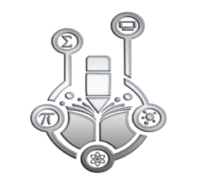

Journal of Advanced Sciences and Mathematics Education
Volume 4, Issue 2, 71 - 79.
e_ISSN: 2798-2351
DOI: 10.58524/jasme.v4i2.381
DEVELOPMENT OF GEOGEBRA BASED INTERACTIVE MULTIMEDIA ON TRIANGLE AND QUADRILATERAL MATERIAL TO IMPROVE MATHEMATICAL CONCEPT UNDERSTANDING ABILITY STUDENTS
Achmad Buchori | Fina Ismatul Uyun | Dhian Endahwuri
Universitas PGRI Semarang | Pendidikan Matematika Universitas PGRI Semarang | Universitas PGRI Semarang

Article Info | Abstract
Article history: | Understanding mathematical concepts is very important for students to develop because it is the basis for developing other mathematical abilities. One effort to improve students' ability to understand mathematical concepts is to use geogebra-based interactive multimedia. The aim of this research is to determine the validity, practicality and effectiveness of geogebra-based interactive multimedia to improve students' ability to understand mathematical concepts. The research method used is Research and Development (RnD) using the ADDIE development research design. The results of the research are (1) the development of geogebra-based interactive multimedia on valid triangle and quadrilateral material to improve the ability to understand mathematical concepts for grade 7 students. This can be seen from the assessment by material expert validation which gave a result of 88% and media expert 88.2%. (2) Learning with geogebra-based interactive multimedia on practical triangle and quadrilateral material to improve class students' ability to understand mathematical concepts. This can be seen from the results of the student response questionnaire, (3) Learning with geogebra-based interactive multimedia on triangles and quadrilaterals is effective in improving the ability to understand mathematical concepts in grade 7 students. This is proven by the average of the experimental class being greater than the average. control class average.
Received: May 29, 2024
Accepted: Sept 10, 2024
Published: Dec 15, 2024
Keywords:
Geogebra, Multimedia, Concept Understanding

To cite this article: Buchori, Achmad., Uyun, Fina, Ismatul., & Endahwuri, Dhian. (2024). Development of Geogebra-based Interactive Multimedia on Triangle and Quadrilateral Materials to Improve the Mathematical Concept Understanding Ability Students. Journal of Advanced Sciences and Mathematics Education, 4(2), 71 - 79. https://doi.org/10.58524/jasme.v4i2.381
INTRODUCTION

In this day and age, science and technology are advancing and developing along with the times. Along with the development of the 4.0 revolution, the way humans work is changing to automation or digitalization. One of them is quality education that will create superior human resources and be useful in advancing a country. One of the influences in the world of education is in school activities, where new information and knowledge spreads quickly and is easily accessible to anyone who needs it. One of the sciences needed to face the era of the industrial revolution 4.0 and improve mastery of science and technology is mathematics (Anggraeni et al., 2021) .

Mathematics is one component of a series of subjects that have an important role in education. Therefore, mathematics is taught in formal and non-formal schools from basic education to higher education, even from an early age children have been taught about calculations and introduced to numbers. Mathematics has an important role in various disciplines and develops human thinking. For that required understanding good concepts in learning mathematics (Anggraeni et al., 2021) .

* Corresponding author:
Achmad Buchori, Pendidikan Matematika Universitas PGRI Semarang
achmadbuchori@upgris.ac.id

One of the efforts to improve the ability to understand concepts is to use learning media in teaching math concepts to students. Learning media is a tool that helps the learning process. Learning media are tools, methods, and techniques used to streamline the process of delivering information by teachers to students in the teaching and learning process at school (Hilmi, 2019) . Based on previous research, the development of geogebra-based learning media for quadrilateral and triangle material for grade 7 SMP Datok Sulaiman Palopo has met the criteria of validity, practicality and effectiveness (Anggraeni et al., 2021) . Based on this research, it states that the learning outcomes of students taught using learning media assisted by the google sites website are higher than the average student learning outcomes (Lamaka et al., 2023) .
Concept understanding ability is the ability to interpret, interpret and conclude a mathematical concept based on the formation of their own knowledge, not just memorizing so that they are able to explain the concepts obtained either orally or in writing. The ability to understand concepts is very important so that solving problems can be structured. According to Rahmawati & Roesdiana (2022) the problem that occurs when in mathematics learning activities is that students do not understand the concept of the material being taught because students are only encouraged to memorize formulas. Concept understanding ability as the root of student thinking to develop all students' thinking abilities ( Rahmawati & Roesdiana 2022) . Students with good concept understanding will be able to solve various types of mathematical problems well (Sari et al., 2022) .
One of the efforts to improve students' ability to understand mathematical concepts is to use interactive multimedia during learning in understanding students' mathematical concepts. Interactive multimedia is a tool that helps the learning process. Interactive multimedia is a medium that combines text, sound, animated images, and video to convey messages through electronic media. According to Astri et al., (2022) states that interactive multimedia allows students to interact with the media as a learning resource.
Interactive multimedia can be used during offline and online learning ranging from web forms to applications on computers and smartphones (Ika et al., 2021) . In this digital era, interactive multimedia can be utilized as a learning tool in the form of computers and smartphones.
The use of geogebra-based math learning can produce benefits students so that it is hoped that students can get an increase in students' mathematical concept understanding abilities. Based on previous research, research by Yanti et al., (2019) that there is a significant difference in increasing the understanding of mathematical concepts of students who apply a scientific approach assisted by geogebra and who use ordinary learning. While research by Mukarramah et al., (2022) states the results of research entitled the effect of using geogebra software on students' concept understanding and mathematical problem solving abilities, illustrating that (1) there is a significant positive effect between the use of geogebra software on students' mathematical concept understanding abilities, (2) there is a significant positive effect between the use of geogebra software and students' mathematical problem solving abilities, and (3) there is a significant positive effect between the ability to understand mathematical concepts and students' mathematical problem solving abilities.
Research by Sonia et al., (2023) shows that the improvement in mathematical concept understanding ability of students who obtain AIR learning model assisted by geogebra is better than students who obtain conventional learning model and students' attitude is positive towards learning mathematics by using AIR learning model assisted by geogebra. The development of geogebra-based learning media can improve students' concept understanding ability, the results of using the media are 3.69 with an average of 89% of learning media can be implemented in the high category with a practical level of practicality (Anggraeni et al., 2021) .
Based on the description that has been presented, researchers are interested in conducting research on the development of geogebra-based interactive multimedia on triangle and quadrilateral material to improve the ability to understand mathematical concepts of grade 7 students.
RESEARCH METHODS
The research method used is Research and Development (RnD). This research uses the ADDIE development research design which consists of five stages, namely analysis, design, development, Implementation, Evaluation to develop geogebra-based interactive multimedia on quadrilateral and triangle material. This research produces learning media in the form of geogebra-based interactive multimedia on quadrilateral and triangle material. The subjects of this study were seventh grade students in the 2024/2025 school year with a total of 33 students. The data collection techniques used were observation, tests, interviews and documentation.

RESULTS AND DISCUSSION
The development of geogebra-based interactive multimedia on triangle and quadrilateral material was carried out at SMP Negeri 2 Sayung in accordance with development procedures that refer to the ADDIE model, namely based on the stages of analysis, design, product development, implementation and evaluation.
          - Analysis Stage
The analysis stage is carried out by observing teaching materials and media that have been used as learning resources in the learning process. Learning resources are only guided by one book obtained from the government. So that in increasing student knowledge, other learning resources are needed. Therefore, researchers developed an interactive math learning multimedia and were able to motivate students in the learning process. Researchers chose geogebra and canva software with the PBL model, so that students are motivated in the learning process and can improve their ability to understand mathematical concepts. research Tamami, (2021) has proven that learning using geogebra-based interactive media is valid, interesting, effective. Learning with the AIR model assisted by geogebra is better so that it can improve students' understanding of mathematical concepts (Sonia et al., 2023) .
          - Design Stage
After the analysis stage, the next is the design stage. This stage includes preparing the structural framework of the geogebra-based interactive multimedia to be created, what researchers do is analyze the material displayed, analyze the display design, determine evaluation questions, design videos. Furthermore, determining the instrument used is a type of questionnaire given to media experts, material experts and students who are the subject of research. The validation sheet for media experts and material experts is in the form of a questionnaire using a five scale whose assessment scale criteria strongly agree given a score of 5, if you agree given a score of 4, neutral given a score of 3, disagree given a score of 2, and strongly disagree given a score of 1. While the instrument for research subjects is in the form of an evaluation test and a student response questionnaire. At the design stage by research Pratama et al., (2023) prepared materials and designs or rough drawings related to interactive learning multimedia based on articulate stroryline with the help of geogebra which will be developed in the form of storyboards. At the design stage by research Iswara & Cahdriyana, (2022) made a design of combining various media combined with geogebra to help student visualization which then produced a product in the form of HTML5.

Before revision
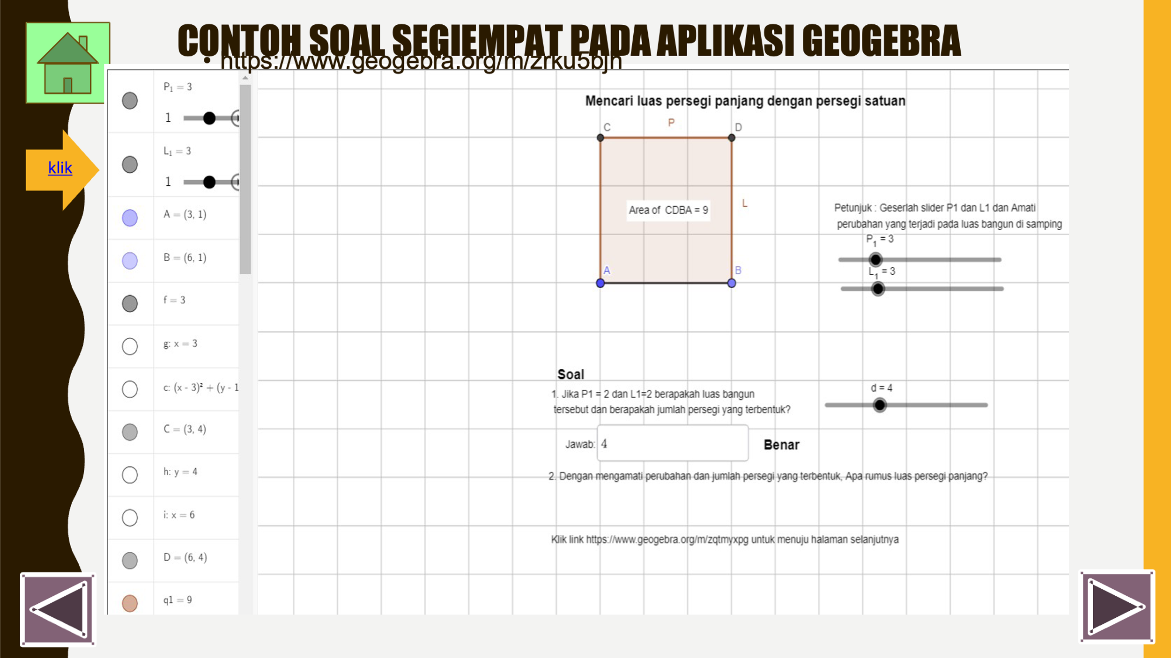
Figure 1. example material of square with geogebra before revison

After revision
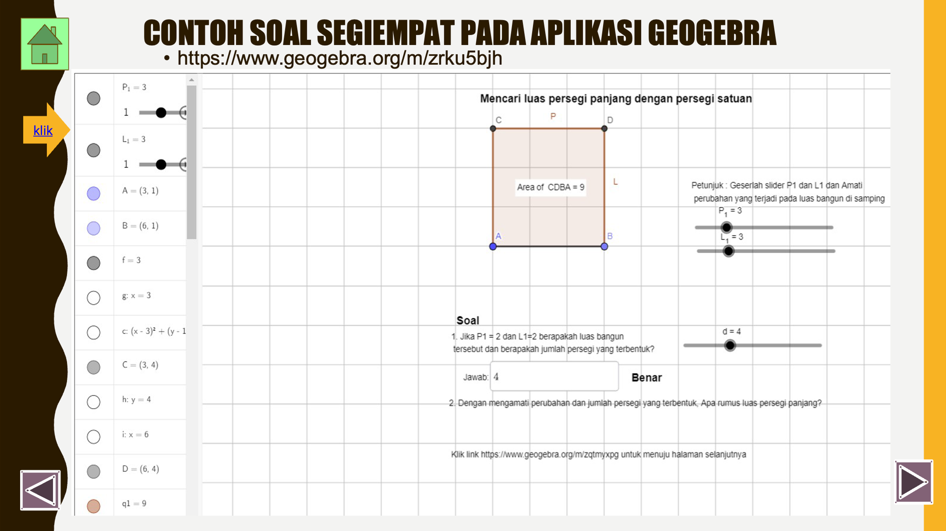
Figure 2. example material of square with geogebra after revision

          - Development Stage
After the design stage, then do the development stage. At this development stage, it produces geogebra-based interactive multimedia on triangle and quadrilateral material through the pre-research stage. The pre-research in question is to validate the product to 3 media experts and 3 material experts.
The results of the validation of the three media experts based on the eligibility criteria obtained an average of 88.2%. From the results of the media expert validation, it can be interpreted that geogebra-based interactive multimedia is very good and feasible to use with revisions according to suggestions from media experts. This media validation indicator consists of 4 aspects, namely: general aspects, presentation aspects, language aspects and media graphics aspects.
Next is validation by material experts. The results of the validation of the three material experts based on the eligibility criteria obtained an average of 88%. From the results of the material expert validation, it can be interpreted that this geogebra-based interactive multimedia is in the very good category (feasible) to use even though revisions need to be made according to suggestions from material experts. This material validation indicator consists of 3 aspects, namely: general aspects, material substance aspects, and learning design.
The validation results are used as a draft and then editing and revision are carried out so that the next stage can be carried out, namely the implementation stage. At the development stage by research Pratama et al., (2023) this stage has been compiled and the storyboard has been designed with the software to be used and the results will be prototype 1 or multimedia that is not yet feasible. At the development stage by research Iswara & Cahdriyana, (2022) consists of expert validation and development tests.
          - Implementation Stage
At the implementation stage, this stage is the instrument trial. Evaluation test instruments need to be tested to determine the validity, reliability, level of difficulty and differentiation of the questions. This trial was conducted to determine the feasibility of the evaluation question. After discussing with the mathematics teacher of SMPN 2 Sayung, the researcher chose class IX-A as the trial class. In the trial question, 10 essay questions will be tested.
The results of the trial analysis of 33 students of class IX-A obtained valid questions as many as 10 questions. Furthermore, the calculation of the level of difficulty is known to be 1 difficult category question and 9 easy category questions. Then from the analysis of the differentiating power of the question it is known that 10 questions have good differentiating power.
After testing the instrument, the researcher conducted a product usage test. At the product use test stage, researchers chose class VII-G with 33 students as the experimental class and class VII-F with 32 students as the control class. The initial analysis of the two classes was taken from the pre-test scores of students' mathematical concept understanding abilities. This implementation stage is in line with the research of Zaharah et al., (2021) the Implementation stage is carried out or applied in actual classroom situations with actual teaching using quantum learning-based mathematics learning multimedia. At the implementation stage by research Aspriyani & Suzana, (2020) at this stage, the e-modules developed are used by teachers in the learning process and observed to record things that need to be improved.
          - Evaluation stage
At the evaluation stage, researchers analyzed the initial and final data. For the normality test in this study, the Lilliefors test was used. The initial data normality test was carried out using spps 2.0 software. Based on the significance value in the test of normality table, the significance value in the control class is 0.797 and in the experimental class is 0.407. Because 0.797> 0.05 and 0.407> 0.05 then Ho is accepted. The conclusion is that the samples in the experimental class and control class come from a normally distributed population. To test the homogeneity of the two classes using the bartlett test. Based on the results of calculations that have been carried out using SPSS, in the test of homogeneity of variances table. Based on the two obtained significance values (probability) the value of Sig.=0.084, then Sig.=0.084> 0.05 so that the H0 hypothesis is accepted. The conclusion is that H0 is accepted, so the two variances of the population in the Experiment class and Control class are the same (homogeneous data).
The final data normality test was calculated using spss 2.3. Based on the significance value in the test of normality table, the significance value in the control class is 0.288 and in the experimental class is 0.361. Because 0.288> 0.05 and 0.361> 0.05 then H0 is accepted. The conclusion means that the samples in the experimental class and control class come from a normally distributed population. The final data Homogeneity test is calculated using spss 2.3. Based on the results of calculations that have been carried out using SPSS, in the test of homogeneity of variances table. Based on the two obtained significance (probability) values Sig.=0.547, then Sig.=0.547> 0.05 so that the H0 hypothesis is accepted. The conclusion is that H0 is accepted, so the two variances of the population in the Experiment class and Control class are the same (homogeneous data).
For the N-gain test using spss 2.3. Based on the results of the output using IBM SPSS 23, the average N-Gain Score for the experimental class was calculated at 0.4883 including in the medium category. In the experimental class, the N-Gain Score ranged from the lowest 0.21 to the highest 0.82. Meanwhile, the average N-Gain Score for the control class is 0.4633, which is included in the moderate category, making it one of the low scores. The N-Gain scores in the control class ranged from a low of 0.25 to a high of 0.80. The N-Gain value provides evidence that the use of interactive multimedia learning models based on geogebra can improve the ability to understand mathematical concepts on quadrilateral and triangle material.
After implementing geogebra-based interactive multimedia learning, then to find out the students' response to the product. Researchers gave a student response questionnaire sheet to 33 experimental class students. The assessment questionnaire contains 30 questions with each question having a maximum value of 5 and a minimum value of 1. The maximum percentage will be achieved by 100%. The results of student responses to learning with interactive multimedia based on geogebra are very good results, many of the students feel very happy in learning and better understand the material. Among the 33 children who became respondents, the highest response value was 95.3% and the lowest response value was 70.7% and the average student response value was 95%, this average was in the very good category
The advantage of the product that has been implemented is that grade 7 math learning students can learn independently from geogebra-based interactive multimedia. This product can be implemented anywhere using the internet. The product is stated to be able to improve the ability to understand mathematical concepts of grade 7 students.
It can be concluded that learning by using geogebra-based interactive multimedia with Problem-Based Learning (PBL) model is better than conventional learning at SMPN 2 Sayung grade VII on triangles and quadrilaterals. This shows that learning using geogebra-based interactive multimedia can improve students' mathematical concept understanding abilities on triangle and quadrilateral material.
This is in accordance with research (Anggraeni et al., 2021) which states that the development of geogebra-based learning media on quadrilateral and triangle material for grade 7 SMP Datok Sulaiman Palopo has met the criteria for validity, practicality and effectiveness. This is also supported by research Yanti et al., (2019) which states that there is a significant difference in increasing the understanding of mathematical concepts of students who apply a scientific approach assisted by geogebra and who use ordinary learning. While research by Mukarramah et al., (2022) states the results of research entitled the effect of using geogebra software on students' concept understanding and mathematical problem solving abilities, illustrating that there is a significant positive effect between the use of geogebra software on students' mathematical concept understanding abilities.

CONCLUSIONS AND SUGGESTIONS
Based on the research data, it can be concluded that (1) The development of geogebra-based interactive multimedia on the triangle and quadrilateral material of SMPN 2 Sayung is valid to improve the ability to understand the mathematical concepts of grade 7 students. This can be seen from the assessment by material expert validation and media expert validation which provides excellent category results. (2) Learning with geogebra-based interactive multimedia on triangle and quadrilateral material is practical to improve the ability to understand the mathematical concepts of grade 7 students. This can be seen from the results of student responses to geogebra-based interactive multimedia has an average with a very good category. (3) Learning with geogebra-based interactive multimedia on triangle and quadrilateral material is effective for improving the ability to understand mathematical concepts of grade 7 students. This is evidenced by the results of significant regression values, so that there is an influence between the ability to understand the mathematical concepts of students taught with geogebra-based interactive multimedia learning in the experimental class better than the ability to understand the mathematical concepts of students taught with conventional learning in the control class.

LITERATURE
Anggraeni, E. R., Ma'rufi, M., & Suaedi, S. (2021). Development of Geogebra-based Mathematics Learning Media to Improve Students' Concept Understanding Ability. Proximal: Journal of Mathematics Research and Mathematics Education,4(1), 43–55. https://doi.org/10.30605/proximal.v4i1.503
Arifin, Z. (2013). Learning Evaluation. Bandung: PT Remaja Rosdakarya.
Arikunto, suharsimi. (2007). Basic Basics of Educational Evaluation. Jakarta: Bumi Akasara.
Aspriyani , R., & Suzana, A. (2020). This R&D aims to produce interactive e-modules based on circle material. AKSIOMA: Journal of Mathematics Education Study Program,9(4), 1099–1111. https://doi.org/https://doi.org/10.24127/ajpm.v9i4.3123
Astri, N., Wiarta, I., & Wulandari, I. (2022) . Development of Interactive Multimedia Based on Contextual Approach in Mathematics Subject of Flat Buildings at Tuanku Tambusai Heroes University. Journal of Education and Counseling, 4(3), 575–585.
Department of Education. (2006) . Permendiknas No 22 of 2006 concerning Content Standards. Jakarta: Ministry of Education.
Dr. H. Heris Hendriana, M. P., Dr. Hj. Euis Eti Rohaeti, M. P., & Sumarmo, P. D. H. U. (2017). Hard Skills and Soft Skills of Mathematics Students (N. F. Atif (ed.); 1st ed.). PT Refika Aditama.
Fitriani, N., Hidayah, I. S., & Nurfauziah, P. (2021). Realistic Mathematics Education Live Worksheet Assisted by Geogebra: Improving Mathematical Abstraction of Junior High School Students on Quadrilateral Material. JNPM (National Journal of Mathematics Education),5(1), 37. https://doi.org/10.33603/jnpm.v5i1.4526
Hilmi, R. A. (2019) . Math Learning Media (Mobile Learning) Based. 115–124.
I.G.N.J.A. Pratama, I.G.P. Sudiarta, & I.N. Sukajaya. (2023). Development of Interactive Learning Multimedia Based on Articulate Storyline with Geogebra Assistance on Geometric Transformation Material. Indonesian Journal of Mathematics Education and Learning,12(1), 22–33. https://doi.org/10.23887/jppmi.v12i1.1445
Ika, R., Pratiwi, M., & Wiarta, I. W. (2021). Interactive Multimedia Based on Indonesian Realistic Mathematics Education in Mathematics Learning. 8(1), 85–94.
Iswara, L., & Cahdriyana, R. A. (2022) . Development of Interactive Multimedia Using Articulate Storyline Assisted by Geogebra on Line and Angle Materials for Junior High School Students. Proximal: Journal of Mathematics Research and Mathematics Education,6(1), 79–87. https://doi.org/10.30605/proximal.v6i1.2073
Jabar, S. A. and C. S. A. (2008). Education Program Evaluation. Jakarta: Bumi Aksara.
Khairunnisa, A., Gozali, S. M., & Juandi, D. (2022) . Systematic Literature Review: Students' Mathematical Understanding Ability in Solving Mathematical Problems. 06(02), 1846–1856.
Lamaka, R. A. Y., Zakaria, P., & Isa, D. R. (2023). The Effect of Learning Media Assisted by Google Sites Website on Student Learning Outcomes on Quadrilateral and Triangle Materials. Rizky. 6(September), 87-95.
Manurung, P. (2020) . Interactive Multimedia as Learning Media during the COVID Pandemic 19 Purbatua Manurung. Al-Fikru: Scientific Journal, 14(1), 1–12.
Marfu, S. (2022). Mathematics Learning Model to Improve Students' Mathematical Reasoning Ability5, 50–54.
Masdar Limbong, Firmansyah, Fauzi Fahmi, & Rabiatul Khairiah. (2022). Learning Resources Based on Interactive Learning Media in Schools. Decode: Journal of Information Technology Education,2(1), 27–35. https://doi.org/10.51454/decode.v2i1.27
Mukarramah, Edy, S., & Suryanti, S. (2022) . The Effect of using Geogebra Software on Students' Concept Understanding and Mathematical Problem Solving Skills.11(1), 67–80. https://doi.org/10.25273/jipm.v11i1.13309
Mulyasa. (2014). Development and Implementation of the 2013 Curriculum. Bandung: PT Remaja Rosdakarya.
Muzdalipah, I., Rustina, R., Patmawati, H., & Yulianto, E. (2023). Development of Teaching Materials Using Geogebra on Triangle and Quadrilateral Materials. Theorem: Mathematics Theory and Research,8(1), 181. https://doi.org/10.25157/teorema.v8i1.10090
Pribadi, B. A. (2009). Learning System Design Model. Jakarta: Dian Rakyat.
Rahmawati, L. R. (2022). Analysis of high school students' mathematical concept understanding ability on algebraic function derivative material. 8(1).
Saas Asela, Unik Hanifah Salsabila, Nurul Hidayah Puji Lestari, Alfi Sihati, A. R. P. (2020). The Role of Interactive Media in Pai Learning for Visual Student Learning Styles. Journal of Research Innovation, 1(3), 599–597.
Sari, F. Y., Supriadi, N., Wahyu, R., Putra, Y., Tarbiyah, F., Raden, U. I. N., & Lampung, I. (2022). CUPs Learning Model Assisted with Handout Media: Impact on Mathematical Concept Understanding Ability in terms of Cognitive Style. 11, 95–106.
Sengkey, D. J., Sampoerno, P. D., & Aziz, A. (2023). Mathematical concept understanding ability: a literature review. 3, 67–74.
Sonia, A., Aminah, M., & Sholihat, M. N. (2023). The Use of Auditory Intellectually Repetition (Air) Learning Model Assisted by Geogebra to Improve Mathematical Concept Understanding Ability (Quasi-Experimental Research on Class VIII Students of SMP Negeri 2 Tanjungsiang for the 2021/2022 Academic Year)2(1), 18–27.
Sudjana. (2005). Statistical Methods. Bandung: Tarsito. Bandung: Tarsito.
Sugiyono. (2010). Educational Research Methods Qualitative, Quantitative and R&D approaches. Bandung: Alfabeta.
Tamami, R. (2021) . Development of Interactive Teaching Materials Using the Geogebra Application on Circle Material. Teknodik Journal,25(1), 1. https://doi.org/10.32550/teknodik.v25i1.649
Yanti, R., Laswadi, Ningsih, F., Putra, A., & Ulandari, N. (2019) . Application of the Geogebra-assisted Scientific Approach in an Effort to Improve Students' Mathematical Concept Understanding. 10(2), 180–194.
Zaharah, N., Marzal, J., & Effendi-Hsb, M. H. (2021) . Development of Quantum Learning-Based Mathematics Learning Multimedia on Quadrilateral and Triangle Materials to Improve Mathematical Communication Skills. Cendekia Journal: Journal of Mathematics Education,5(3), 2768–2782. https://doi.org/10.31004/cendekia.v5i3.733

