Symmetries of the Equilateral Triangle mediated by GeoGebra: a proposal for training rural mathematics teachers

First Author* | Second Author | Third Author
University/Affiliation,  COUNTRY | University/Affiliation,  COUNTRY | University/Affiliation,  COUNTRY

Article Info |  | Abstract
Article history:  Received: Month XX, 20XX  Revised: Month XX, 20XX  Accepted: Month XX, 20XX  (Cambria 9) |  | The didactic proposal on the use of GeoGebra for teaching the symmetries of the equilateral triangle in the training of rural mathematics teachers. The introduction contextualizes the importance of geometry and the need for didactic approaches that consider the reality of the countryside. The main objective was to investigate the potential of GeoGebra as a mediating tool in the understanding of symmetries. The methodological path adopted a qualitative and descriptive approach, with data collection through observation, analysis of students' productions in GeoGebra and interviews. The results demonstrated that the software facilitates the visualization and manipulation of geometric transformations, contributing to the construction of knowledge about symmetries in an active and meaningful way. The final considerations highlight the relevance of the proposal for the training of rural teachers, considering the accessibility of GeoGebra and the possibility of contextualizing the content with the local reality, in addition to suggesting future research on the topic.
Keywords:
Symmetries
Triangle
Equilateral
GeoGebra
Mathematics

To cite this article: Author. (20XX). Title. International Journal of Applied Mathematics, Sciences, and Technology for National Defense, X(X), XX-XX

INTRODUCTION
The equilateral triangle, due to its high regularity, presents several symmetries. In the field of Mathematics, Geometry investigates the nature of shapes, their relative positions and the characteristics that define them as geometric entities (Lorenzato, 2006). The study of the symmetries of the equilateral triangle allows a deep understanding of its geometric characteristics, such as the equality of its sides and angles, in addition to the coincidence of notable points.
The understanding of symmetries has benefited from the development of dynamic geometry software such as GeoGebra. GeoGebra, a dynamic mathematics software for schools that combines geometry, algebra and calculus. The use of GeoGebra allows the visualization and interactive manipulation of symmetries, facilitating the understanding of the concepts involved (Hohenwarter; Kovács; Recio, 2019).
Teacher training for the field context requires pedagogical approaches that consider the reality of the students. Exploring the axioms of equilateral triangle symmetry can be a valuable tool in this process, allowing the connection between formal geometry and practical knowledge.
GeoGebra offers resources for the construction and analysis of various plane figures, including the triangle. Digital technologies offer teachers the means to explore mathematical ideas in a way that was not possible with traditional materials (Ponte; Brocardo; Oliveira, 2009). The software allows interactive visualization of symmetries, facilitating the understanding of concepts such as reflection, rotation and translation.
The objective of this research is to investigate the potential of using GeoGebra in the teaching and learning of equilateral triangle symmetries, seeking to understand how technological mediation can contribute to the development of geometric reasoning in mathematics teachers. In addition, the aim is to find an approach to equilateral triangle symmetries that can be integrated into teacher training, considering the need for contextualized pedagogical practices, including in the context of rural education.

METHOD
The methodological approach of this teaching proposal, which uses GeoGebra as a mediating tool, adopts a qualitative and descriptive approach. Qualitative research produces descriptive data: written or spoken words and observable behavior (Bogdan; Biklen, 1994). In this sense, data collection will focus on observing teachers' interactions with the software, analyzing their productions (symmetry groups, written records, among others) and on possible reports or interviews.
The descriptive nature of the research seeks to detail and interpret the phenomena observed in teacher training, seeking to understand how the use of GeoGebra influences the teaching and learning process of the geometric concepts in question, without the intention of statistical generalizations, but rather of an in-depth understanding of the specific context in which the proposal is applied.

Literature Review
The origins of group theory date back to the early 19th century, with the work of mathematicians such as Paolo Ruffini and Niels Henrik Abel on the impossibility of solving polynomial equations of degree five or higher by radicals. However, it was Évariste Galois who laid the formal foundations of the theory, associating groups with polynomial equations and showing that solvability by radicals is intrinsically linked to the structure of the associated group. Galois created the concept of group as a tool to investigate the solvability of algebraic equations. This revolutionary approach paved the way for the development of group theory as an autonomous field of mathematics (Wussing, 1984).
Parallel to the development of group theory from algebraic equations, the study of symmetry groups emerged. Arthur Cayley, in 1854, provided the first abstract definition of a group, independent of the context of the equations. Felix Klein, in his Erlangen Program (1872), proposed that geometry should be studied through groups of symmetries that preserve certain properties. A group of spatial symmetries; then, the geometric properties are those that are not altered by the symmetries of the group (Klein, 1893). This unifying perspective profoundly influenced the study of geometry.
The idea of ​​symmetry is closely linked to group theory. An object is symmetric if it remains invariant under certain transformations, and the set of these symmetries forms a group. Hermann Weyl, in his classic book Symmetry (1952), explored in depth the relationship between symmetry and groups, covering several areas of science and art. Whenever there is a structure with defined relations between its elements, and whenever I have managed to perform transformations of these elements that leave these relations intact, this group of symmetries is an essential attribute of the structure in question (Weyl, 1952). The equilateral triangle, with its highly symmetrical shape, provides a concrete and accessible example to illustrate the concepts of symmetry groups. The symmetries of an equilateral triangle include three reflections about its perpendicular bisectors and three rotations about its center (including the 0° rotation, which is the identity symmetry). These six symmetries form a group called the dihedral group D3, or the symmetry group of the equilateral triangle. The symmetry group of an equilateral triangle is a standard example of a non-abelian finite group (Armstrong, 1988).
Group theory, which began with the study of algebraic equations and symmetry groups, has found numerous applications in many areas of mathematics, physics, chemistry, computer science, and other disciplines. From the classification of elementary particles in physics to cryptography in computer science, groups play a fundamental role. The ideas of Galois, Klein, and Weyl continue to influence research and teaching in mathematics. Group theory is a powerful tool for studying symmetry and structure in mathematics (Artin, 1991).

Symmetry Group of the Equilateral Triangle
An equilateral triangle has 6 symmetries, which can be described as follows:
(i) Identity: This is the symmetry that does not alter the triangle. It is as if we did nothing to it.
(ii) Rotations: The equilateral triangle has rotational symmetry. We can rotate it around its barycenter (the meeting point of the medians) at two specific angles, in the counterclockwise direction:
120º rotation: By rotating the triangle 120º, it overlaps its original position.
240º rotation: By rotating another 120º (totaling 240º), the triangle also overlaps its original position.
(iii) Reflections: The equilateral triangle also has reflexive symmetry. We can reflect it through three axes of symmetry, which coincide with its medians (line segments that connect a vertex to the midpoint of the opposite side). Each reflection mirrors the triangle in relation to one of these medians (Valladares, 2018).
The combination of these symmetries (identity, rotations and reflections) results in the 6 symmetries of the equilateral triangle. Each of these symmetries corresponds to a permutation of the triangle's vertices. A figure illustrating these symmetries and the corresponding permutations of the vertices would be useful for better visualization.
The symmetries of an equilateral triangle include identity, two rotations (120° and 240°) around the barycenter and three reflections in relation to its medians. Each of these operations corresponds to a permutation of the triangle's vertices.

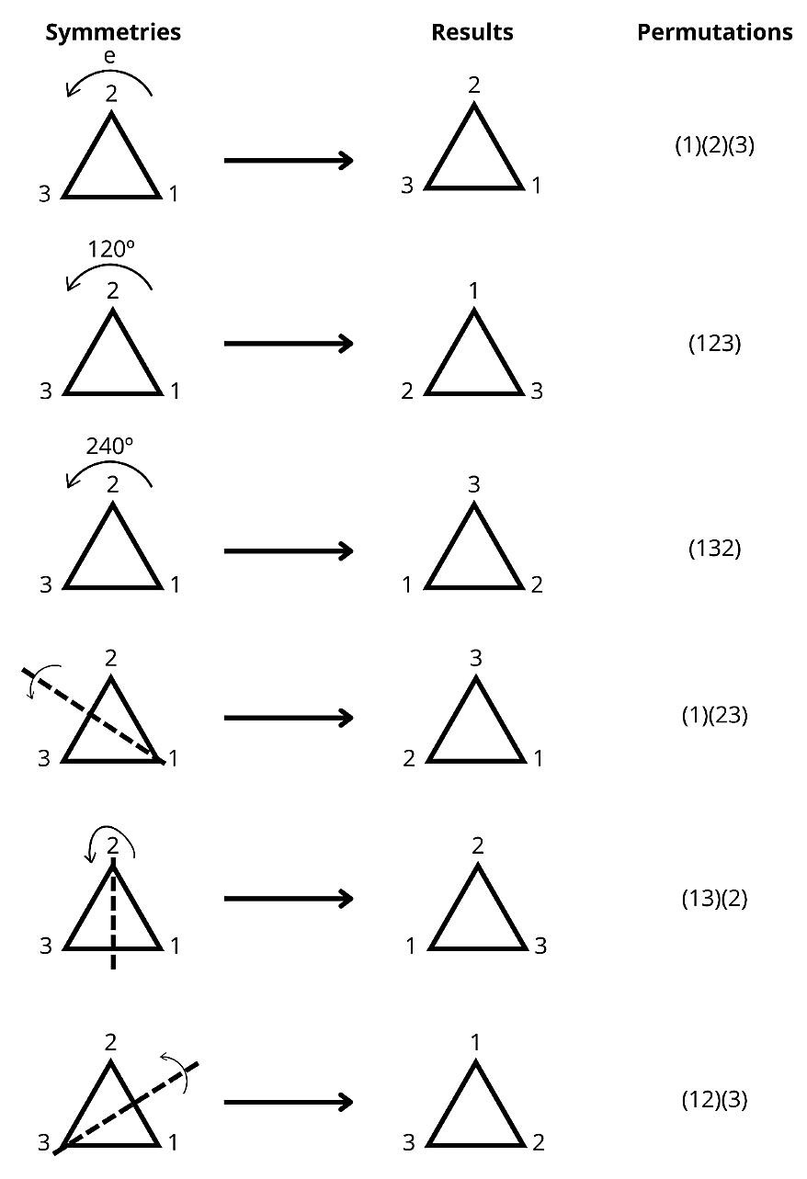
Figure 1. Symmetries of the equilateral triangle

This teaching proposal explores the Symmetries of the Equilateral Triangle of rotation and translation using the GeoGebra software. The goal of GeoGebra is to provide teachers with a visual and interactive understanding of these concepts, connecting geometric intuition with algebraic representation. Rotations involve the movement of an object around a fixed point (center of rotation), while translations consist of the displacement of an object in a specific direction and distance. GeoGebra offers a dynamic environment that facilitates exploration and experimentation with mathematical concepts, allowing subjects to build their own knowledge (Hohenwarter et al., 2008).

Frame 1. Description of basic commands
Rotation:
Create an object: Draw a point, segment, polygon or any other figure that you want to rotate.
Select the Rotation tool: Click on the rotation icon (a point rotating around another).
Select the object to be rotated: Click on the object you drew.
Select the center of rotation: Click on the point that will be the center of rotation.
Set the rotation angle: Enter the value of the desired angle (in degrees or radians) and click “OK”.
Translation:
Create an object: Draw a point, segment, polygon or any other figure that you want to translate.
Select the Translation by vector tool: Click on the translation icon (an arrow).
Select the object to be translated: Click on the object you drew.
Set the translation vector: Click on two points that define the vector (the first point is the starting point of the vector and the second is the end point).

GeoGebra makes it possible to visualize the connection between algebra and geometry. The symmetries of the equilateral triangle, such as rotations and translations, can be represented algebraically by algebraic commands in the construction window. For example, a rotation about the origin in the Cartesian plane can be represented by a rotation matrix.

RESULTS AND DISCUSSION
This algebraic representation allows the precise calculation of the coordinates of the transformed points. Algebra provides a language for describing and generalizing geometric relationships (Usiskin, 1987).

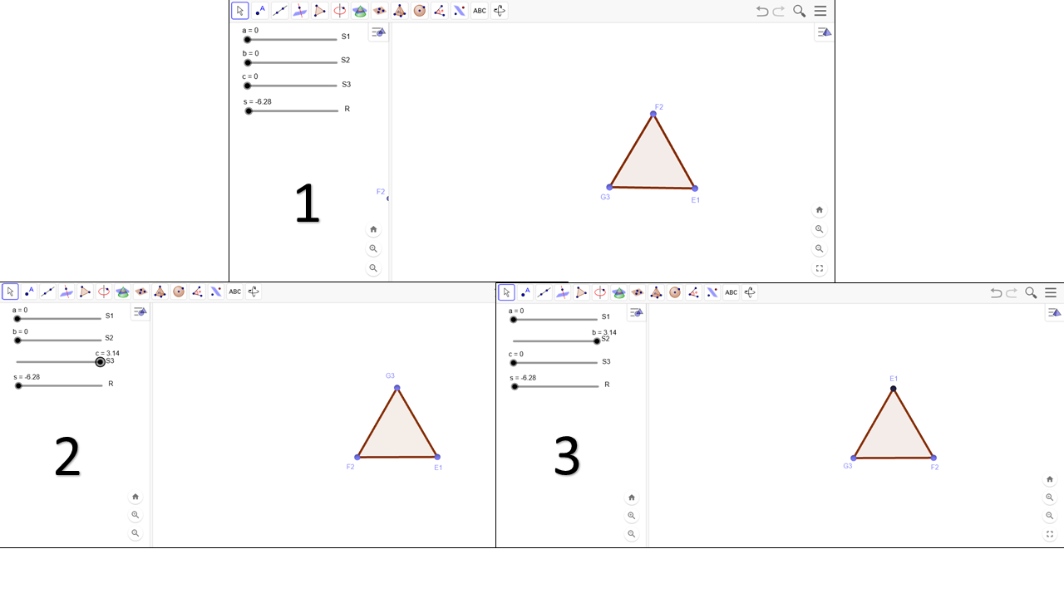
Figure 2. Rotations of the symmetries of the equilateral triangle

The equilateral triangle has a rich set of symmetries, including rotations of 120° and 240° about its center and reflections about its three perpendicular bisectors. These six symmetries form the dihedral group D3. GeoGebra allows the visual construction of these symmetries, facilitating the understanding of the structure of the group. Symmetry is a manifestation of the presence of a symmetry group (Weyl, 1952).

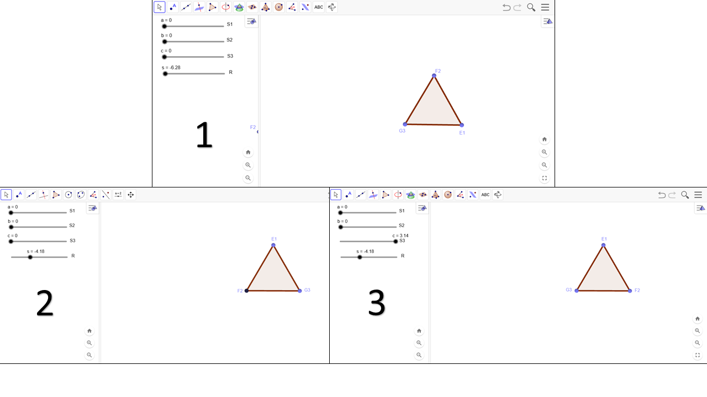
Figure 3. Reflections of the symmetries of the equilateral triangle

An important aspect of group theory is the composition of symmetries. In GeoGebra, it is possible to apply successive symmetries to an object and observe the result. For example, rotating a triangle and then translating it. This visual experimentation helps teachers understand group operations and verify properties such as associativity for a sociocultural practice in the classroom with their students.
The teaching proposal with GeoGebra allows a dynamic and interactive approach to the study of symmetry groups. The connection between algebra and geometry becomes more concrete, facilitating the understanding of the concepts involved. This approach can be applied at different levels of education, adapting the activities to the age group and learning objectives. The use of GeoGebra motivates teachers and provides dynamic learning.

CONCLUSION
The main objective of this research was to investigate the potential of the GeoGebra software as a mediating tool in the teaching and learning process of equilateral triangle symmetries, with a focus on the training of mathematics teachers who work in rural areas. Throughout the study, it was demonstrated that GeoGebra offers a dynamic and interactive environment that facilitates the visualization and manipulation of the symmetries of plane figures, such as reflections and rotations, allowing a deeper understanding of the symmetries of the equilateral triangle. The results revealed that the use of GeoGebra provided future teachers with a concrete and meaningful experience with the concepts of symmetry, breaking away from purely abstract approaches and favoring the active construction of knowledge. The possibility of visualizing transformations in real time and exploring different geometric configurations contributed to the development of geometric reasoning and to the understanding of the group structure present in symmetries. In the specific context of rural teacher training, the didactic proposal proved to be particularly relevant. The reality of rural schools often presents challenges such as lack of resources and the need to adapt content to local conditions. GeoGebra, as a free and accessible software, emerges as a powerful tool to overcome these difficulties, offering visual and interactive resources that can enrich mathematics classes and make learning more meaningful for students. In addition, the approach to the symmetries of the equilateral triangle can be connected to elements of the culture and daily life of rural students, making the content more contextualized and interesting.
This study has important practical implications for the teaching of geometry, by demonstrating the potential of GeoGebra as a pedagogical tool. In addition, it contributes theoretically to the area of ​​mathematics education, by providing support for the training of teachers who are better prepared to use digital technologies in the classroom and to approach geometric concepts in a more dynamic way.
For future research, we suggest investigating the use of GeoGebra in other geometry content, such as the study of other polygons and geometric solids, as well as exploring other features of the software. Furthermore, it would be interesting to investigate the impact of the didactic proposal on the learning of rural students and the teachers' perception of the use of GeoGebra in their pedagogical practices.
AUTHOR CONTRIBUTIONS
Each author of this article played an important role in the process of method conceptualization, simulation, and article writing

REFERENCES
Armstrong, M. A. (1988). Groups and symmetry. Springer Science & Business Media.
Artin, M. (1991). Algebra. Prentice Hall.
Bogdan, R. C., & Biklen, S. K. (1994). Investigação qualitativa em educação: uma introdução à teoria e aos métodos. Porto Editora.
Hohenwarter, M., Hohenwarter, J., Kreis, Y., & Lavicza, Z. (2008). Teaching and learning calculus with free dynamic mathematics software1 GeoGebra. In Proceedings of the 11th International Congress on Mathematics Education (pp. 1629-1636). Monterrey, Mexico.
Hohenwarter, M., Kovács, Z., & Recio, T. (2019). Using Automated Reasoning Tools to Explore Geometric Statements and Conjectures. In: Hanna, G., Reid, D., de Villiers, M. (eds) Proof Technology in Mathematics Research and Teaching. Mathematics Education in the Digital Era, vol 14. Springer, Cham.
Klein, F. (1893). A comparative review of recent researches in geometry. Bulletin of the American Mathematical Society, 2(10), 215-249.
Lorenzato, S. (2006). Para aprender matemática. Campinas: Autores Associados.
Ponte, J. P., Brocardo, J., & Oliveira, H. (2009). Investigações matemáticas na sala de aula. Autêntica Editora.
Valladares, S. Y. (2018). O Teorema de Contagem de Burnside e Aplicações (Master's thesis). Universidade Federal de Mato Grosso.
Usiskin, Z. (1987). Why elementary algebra is important to learn. The Mathematics Teacher, 80(2), 110-117.
Weyl, H. (1952). Symmetry. Princeton university press.
Wussing, H. (1984). The Genesis of the Abstract Group Concept: A Contribution to the History of the Origin of Abstract Group Theory. MIT press.1.

