Math for Olympiad: a didactic proposal for high school from the perspective of the International Mathematical Olympiad

Article Info |  | Abstract
Article history:  Received: Month XX, 20XX  Revised: Month XX, 20XX  Accepted: Month XX, 20XX  (Cambria 9) |  | ABSTRACT  The teaching of Olympic mathematics is increasing every year due to students' participation in national and international mathematical olympiads. This paper aims to present an international Olympic didactic proposal from the perspective of the Theory of Didactic Situations, using digital technology, in particular, the GeoGebra software to be included in the mathematics olympiads discipline. The proposal aims to work the contents of the International Mathematical Olympiad adapting the traditional teaching format with the use of digital technology, the GeoGebra software. This research describes the structuring carried out to build the Olympic mathematical object to be applied by the mathematics teacher. It was evidenced that the GeoGebra software helps in the elaboration of mathematical examples and problem-solving situations.
Keywords:
Didactic Proposal
GeoGebra
Digital Technology
Structuring
To cite this article: Author. (20XX). Title. Journal of Advanced Sciences and Mathematics Education, X(X), XX-XX

INTRODUCTION
With the creation of the first International Mathematics Olympiad (IMO), there was an increasing participation of several countries in the international Olympic tournament, and then mathematics trainings were held for the students selected by each country's delegation, whose purpose is to perform in this competition, since the problems presented in the Olympic tests require a good interpretation of the Olympic question and the ability to reason in the application of formulas to be applied in solving the questions.
The participants from each country are a total of six competitors under the age of twenty, who cannot be enrolled in college, one assistant professor, and one assistant professor. The assistant professor is responsible for looking after the students and substituting for the assistant professor should the need arise during the mathematical tournament.
With the exception of the host country of the international Olympiad, each delegation can submit questions to form the initial IMO database (LongList, LL). Only adjunct professors may submit problem situations according to the competition protocols. These problems cannot have been used or published in previous competitions, and must cover a variety of high school math topics. In recent years, problems have been classified in several areas of mathematics teaching: geometry, number theory, algebra, and combinatorics.
Thus, there are no teaching proposals using digital technology in the teaching material made available by the Brazilian Mathematics Olympiad (OBM), the Brazilian Public Schools Mathematics Olympiad (OBMEP), and there is no concern in the debate about the teaching methods that can be applied in Brazilian high school mathematics Olympiad classes.
In this sense, the objective of this article is to present an international Olympic didactic proposal based on the Theory of Didactic Situations (TSD), using digital technology, more specifically the GeoGebra software to be included in the discipline of Olympiad. Alves (2021), exposes the basic idea of mathematics olympiads include a better quality in mathematics teaching by interaction of competitive and healthy propositions among the participants of mathematical tournaments.
The educational process is important to encourage students to make their own discoveries and develop strategies, as other knowledge, including prior knowledge, is explored in the construction of mathematical solutions. The solution of the proposed activity can only be a teaching process, but the production that occurs allows the construction of knowledge to be used in a classroom educational environment.
Therefore, it is important to include the preparatory lessons in the school planning in advance based on means and tools that stimulate the students' mathematical reasoning capacity. The Didactic Olympic Situation (SDO), develops from an Olympic teaching situation, based on the dialectical phases of the TSD, worked by Alves (2021) and will be used to support the Olympic activities taught by mathematics teachers in the classroom.
Therefore, it will be discussed and presented throughout the article: (i) an IMO international Olympic problem, with the use of GeoGebra, understood as a technological resource for the development and verification of hypotheses by the students; (ii) the construction of teaching situations related to international mathematics Olympic problems; (iii) the structuring of the resolution of the Olympic activity as an object of research and exploration by teachers and students using the GeoGebra software as support.

METHOD
The first IMO competition, held since 1959, has a wide participation with over one hundred participating countries, administered by the International Mathematical Olympiad Council, ensuring that the Olympiad is held annually and that each host country follows the rules and traditions of the IMO (SANTIAGO, 2021).
The purpose of the IMO is to discover, inspire, and challenge students who understand mathematics. In this way, international bonds of friendship are ensured among mathematicians from all participating countries, creating opportunities for exchanges and general dissemination of mathematics.
With this in mind, Kanguru Math Brazil, in conjunction with OBMEP, has several contents to be applied in high school, integrating student participation in problem solving. Compared to other mathematics olympiads, the IMO competition has selection criteria for different participants, has a maximum of six students with a limited target audience. In addition, it has another proposition of open-ended and expository questions, often on fundamental topics that are not publicly available. The same goes for the Southern Cone and Ibero-American Olympiads, the members representing Brazil are students who stand out in the OBM stage, and a considerable number are selected in the final process of each Olympiad, in 4 (four) to 6 (six) members, and other selection criteria.
Mathematics for Olympiads is a discipline from the Catalog of Elective Curricular Units of the state of Ceará, planned to be part of the formative itinerary of Mathematics and its Technologies. The formative itinerary is structured to stimulate and promote the study of Mathematics Olympiad in the classroom and prepare for the stages of learning or the world of work to collaborate to structure solutions to everyday problem situations (Common National Curriculum Base, 2018).
The subject has a workload of two hours per week, addressing the various subjects of Olympic mathematics during an entire bimester. The objects of knowledge presented (Table 1) are proposed for high school students.

Table 1. Mathematical knowledge objects for Olympiads
Arithmetic | Algebra | Counting | Number Theory
Geometry | Financial Math | Techniques for Problem Solving | Digital Technology

The relevance of the issues raised in IMO and their pedagogical treatment in mathematics teaching is well recognized by the academic/scientific community, however, in practice, school, it needs to be included in pedagogical planning to improve knowledge in solving problems with Olympic issues by students.
The structuring of the mathematical proposal for teaching Olympiad is based on TSD, in order to present ways of architecture and work with mathematical content for students. A didactic situation is conceptualized by the emergence of the pedagogical aspects between the teacher, student, and mathematical knowledge (knowing) interconnected to the teaching and learning situation, taking into discussion the milieu. Almouloud (2007), describes that the milieu and didactic situations should include the mathematical knowledges involved in the teaching and learning process of students.
These learning situations bring several issues, possible to be analyzed by the TSD, through the analysis and visualization of the interpretations defined by the student, teacher and knowledge. According to Brousseau (1996), the four stages of the TSD are described: action - situation in which the student simulates the mathematical scheme before the adaptations by interaction of the milieu, taking the decisions that are missing for the structuring of the problem; formulation - happens at the time of exchange of information between the student and the milieu, using the appropriate mathematical language, without the obligation of the explicit use of a formal language.
The student tries to change in a habitual way the language to adapt in communication with other classmates; validation - the class interacts using a mathematical language with the use of demonstrations, allowing the student to follow the paths of his didactic intention mediated by the teacher; institutionalization - is focused on the interaction of the teacher, resumes the part of classroom responsibility checking the resolutions developed by the students. The teacher defines the objects of study through formalization and generalization.
Thus, the TSD has a great importance in the way of interpreting the work built by the students within its four dialectical phases, stimulating the whole class to be participative and interactive for the development of new mathematical knowledge.

RESULTS AND DISCUSSION
It is shown that technological advances exist in teaching and play a crucial role in the transition of teachers' roles (ARTIGUE, 2013). The following describes the necessary procedures and possible methods that can be performed using the geometric constructions visualized in the GeoGebra software. IMO 1959 was carried out in the city of Brașov, Romania. In this sense, the statement of the problem situation of the 1959 IMO, question 5 (five).
The action situation: in this phase they can analyze the understanding of the international Olympiad, build their own decisions and at the end of each mathematical analysis, they observe the answer developed, Almouloud (2007), reports the interactions should happen centrally in decision making between the student and his peer group, the knowledge of this class is part of the milieu of each of the students. This situation constitutes the way in which the student will organize his studies from a mathematical Olympic problem-solving strategy.
An arbitrary point M is selected on the interior of segment AB: Squares AMCD and MBEF are constructed on the same side of AB; with segments AM and MB as their respective bases. The circles circumscribing these squares, with centers P and Q; intersect at M and also at another point N: Let N' be the intersection point of the lines AF and BC:
(a) Prove that points N and N' coincide. In the first construction of the SDO, we observe two segments constructed according to Figure 1.

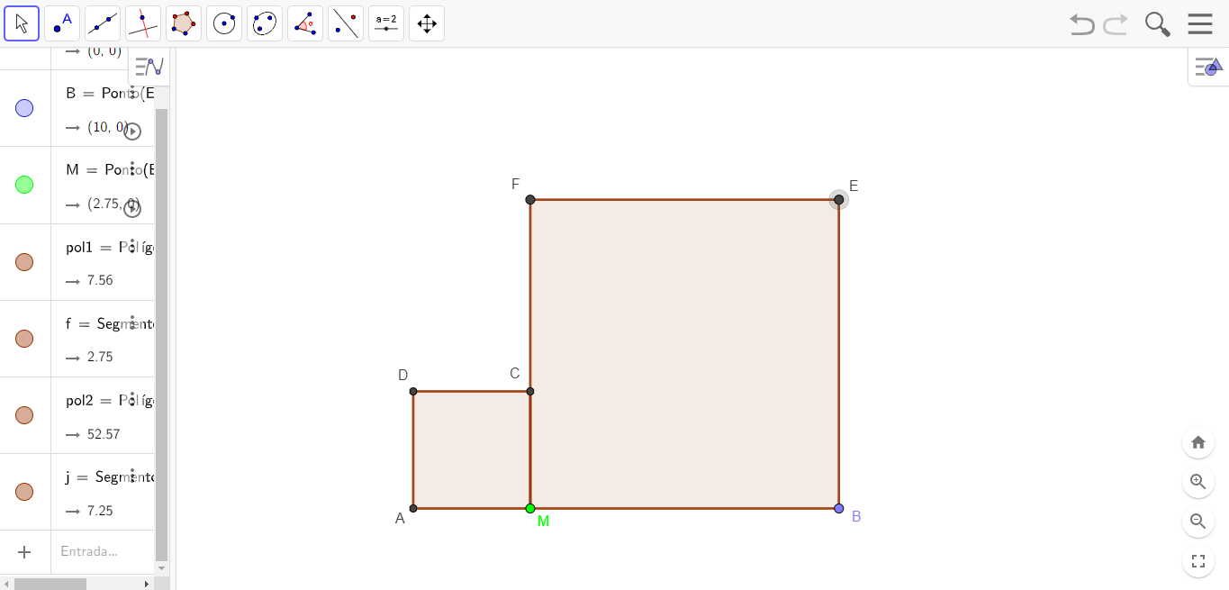

Figure 1. Segments connected to quadrilaterals ADCM and MBEF

In the formulation phase: it is the ability of the subject to recover a knowledge, exchange of information through formal mathematical languages in which everyone can understand. According to Almouloud (2007), the student exchanges information with other participants, they will only be the sender and the recipient of the information of the Olympic didactic situation, exchanging some writings or occurring each one's speech in a natural, or mathematical way.
By tracing the points of the incenter of the quadrilaterals, we have the points FB that intersects Q and the points DM that pass-through P:

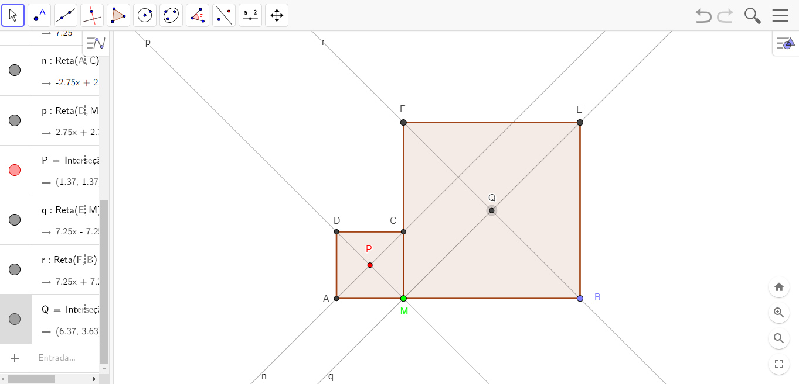

Figure 2. Incenter P and Q

In the third validation step: it allows differentiating new models of mathematical representations: the sender is no longer a notifier of the action, but a supporter, and the recipient is an opponent. The two cooperate to find the correct resolution, meeting the area of knowledge that already exists.
According to Brousseau (1996) highlights that in TSD, students become protagonists of the characteristics of their didactic situation, or does to the relationship between students and the school environment divided into three categories: a) exchange of undiscovered or languageless knowledge (actions and solution); b) exchange of knowledge (information) encoded in a mathematical language (describe); c) exchange of information of the resolution.
In the construction of Figure 3, the two circles circumscribed by the quadrilaterals can be visualized, with meeting points at point M.

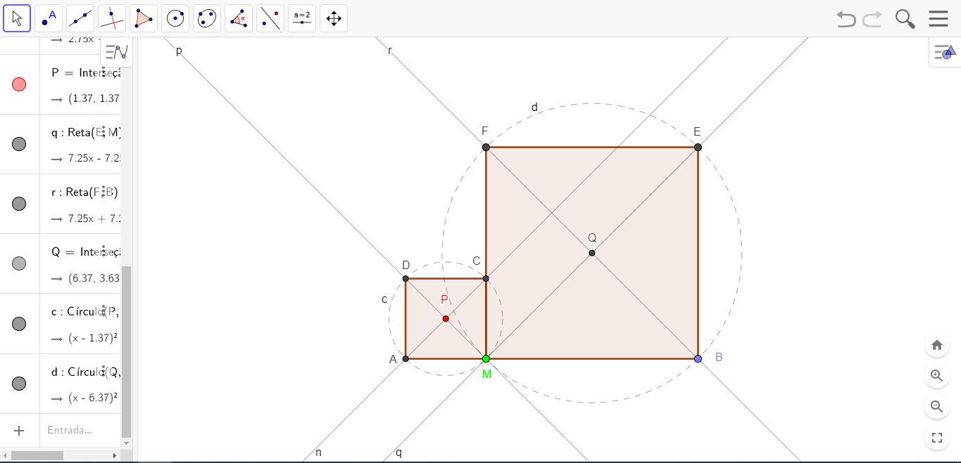

Figure 3. Circumscribed circles

In the last phase of institutionalization: is the step shown in Figure 3, through the visualization of the GeoGebra software window, putting the teacher in the commitment to action, identifying the knowledge for final consideration of all the previous steps, important and unique to the acquired knowledge of the conditioning of the subject.
Already observe that Figure 4, the parameterization of the two straight lines s and t, has the point that intersects at N, passing through the other points F, A, C and B.

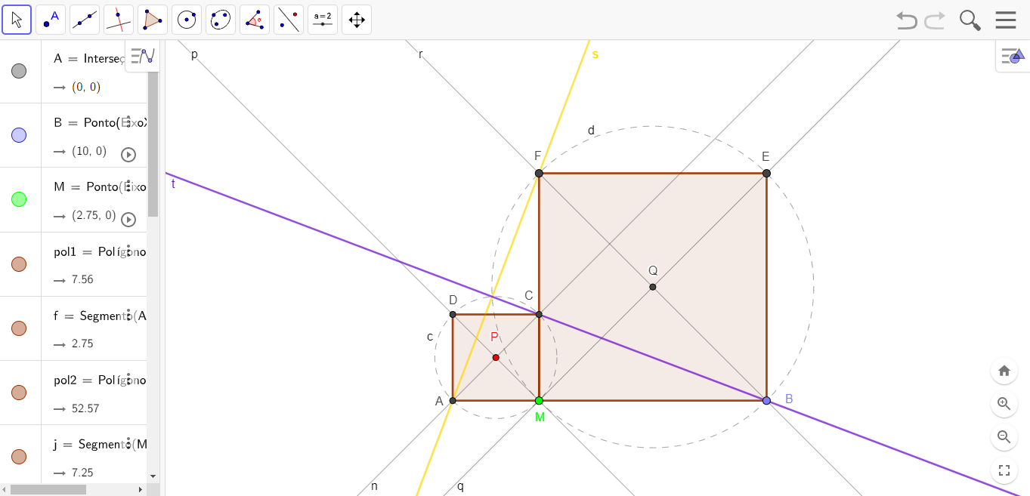

Figure 4. Congruent triangles

Since the triangle’s AFM, CBM are congruent, the angles AFM, CBM are congruent; therefore, NA'B is a right angle. Therefore, N' must lie on the circumcircles of both quadrilaterals; therefore, it is the same point as N.

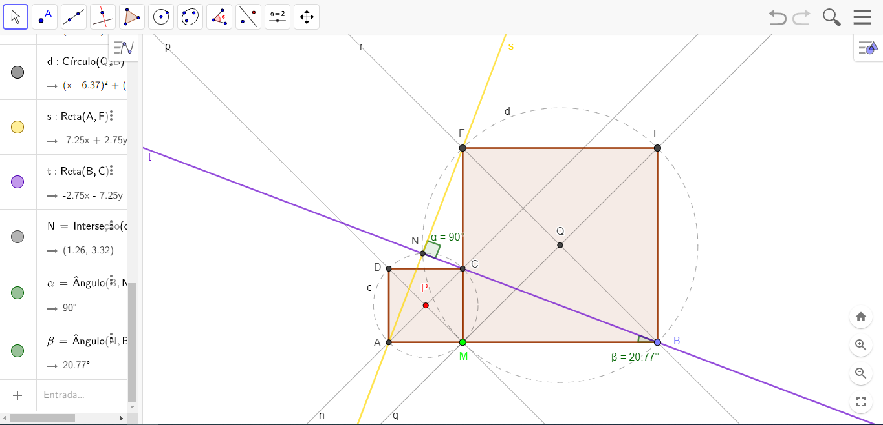

Figure 5. Inscribed quadrilaterals

The GeoGebra construction protocol is a dynamic table that details all the commands performed in structuring the IMO Olympic teaching situation.

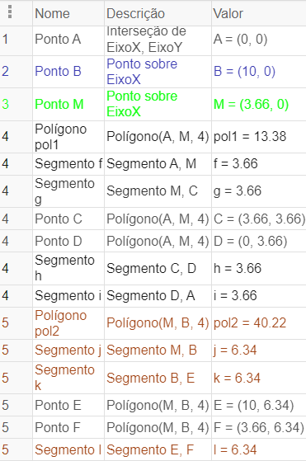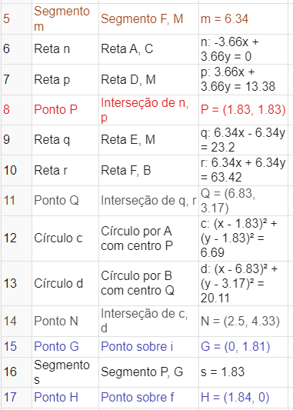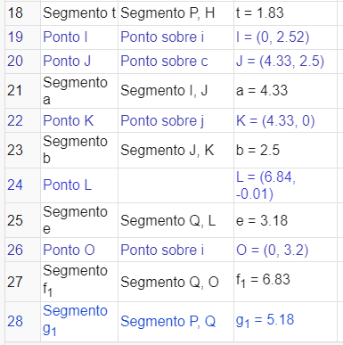

Figure 6. Construction Protocol part 1

(b) Prove that MN lines pass through a fixed-point S independent of the choice of M:
We observe that $\frac{AM}{MB} = \frac{CM}{MB} = \frac{AN}{NB}$ , viewing the triangles ABN, BCM are similar. So, NM goes to the bisector ANB.

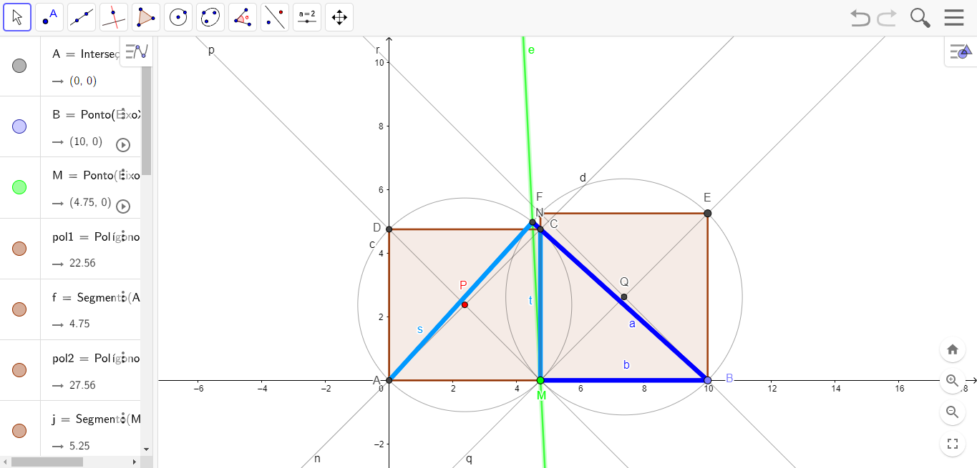

Figure 7. SDO Construction

The parameterization of the lines coincides with the segments starting from A, N, B and M. The points are connected forming a right angle.

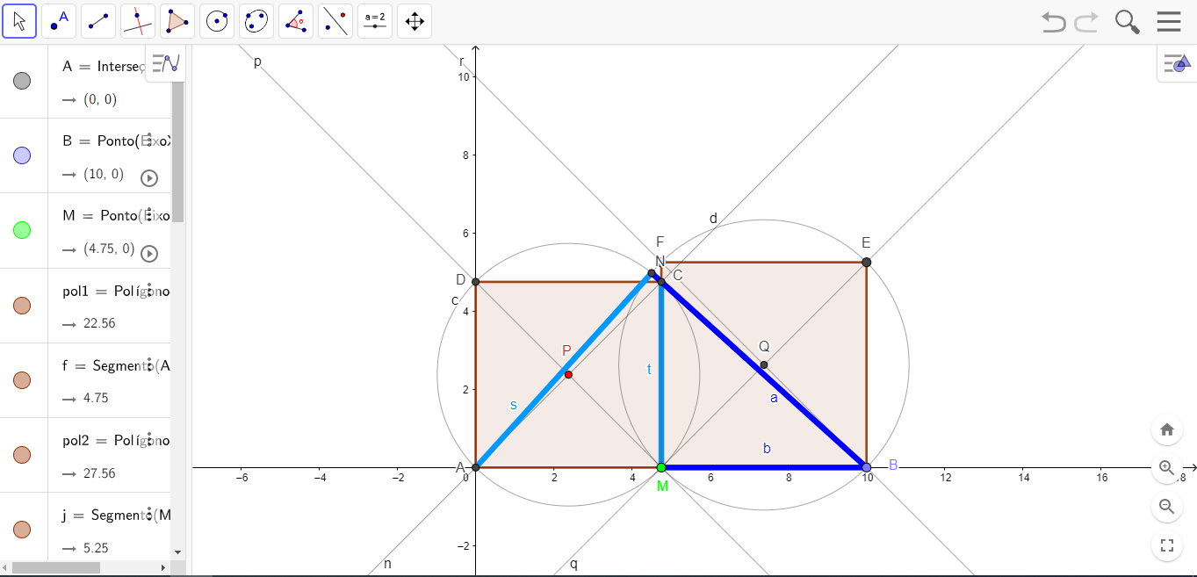

Figure 8. Points intersecting at AFB

To construct another right angle, you create two segments in the quadrilateral AMCD, as illustrated in Figure 9.

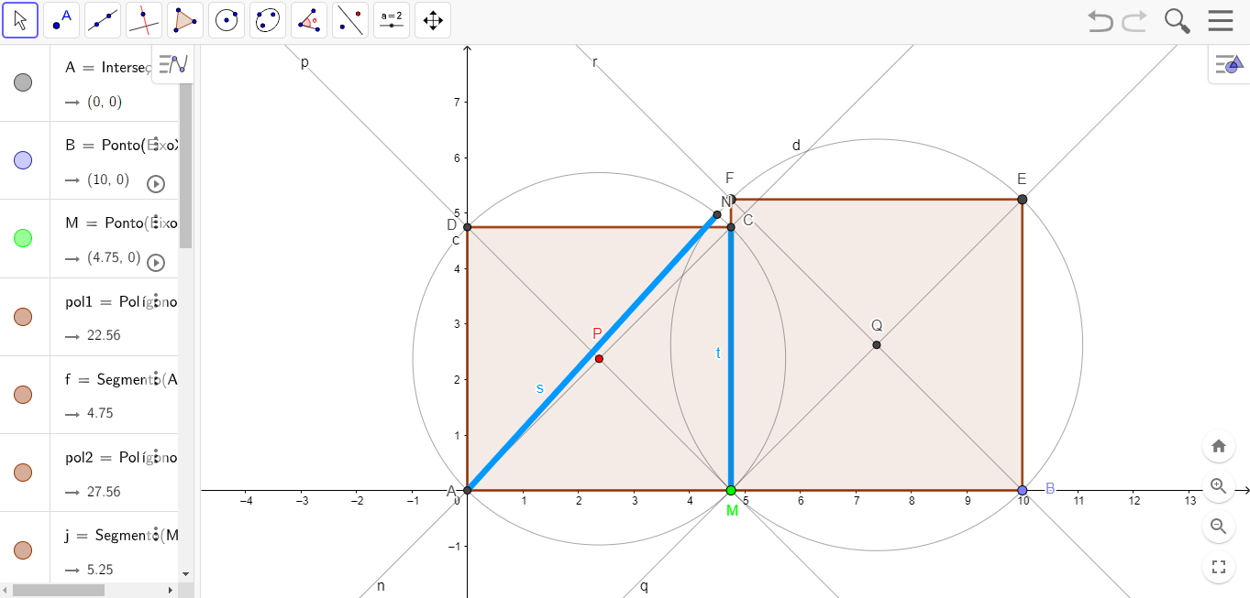

Figure 9. Quadrilaterals circumscribed by the segments AN and MC

Let us now consider the circle of diameter AB. Since ANB is a right angle, N is on the circle, and since MN cuts ANB, the arcs it intersects are congruent, it passes through the bisector of the arc AB (counterclockwise), being a constant point.

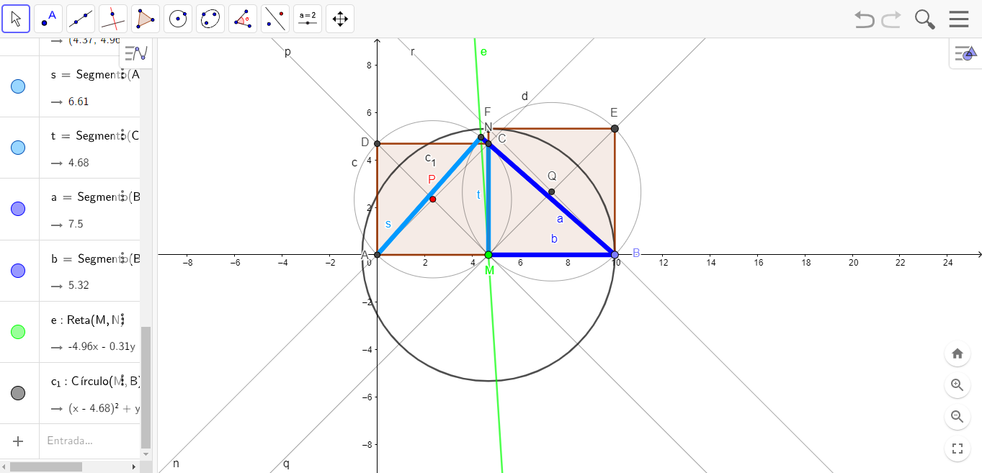

Figure 10. Circumference parallel to quadrilaterals

Given the didactic proposal, the construction protocol in GeoGebra software is presented to be applied in Olympic math classes.

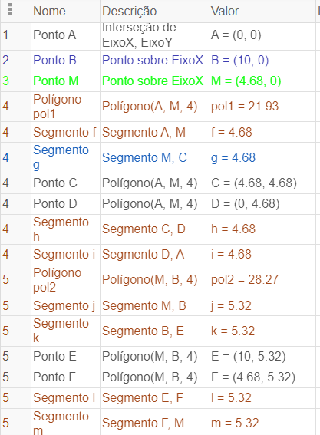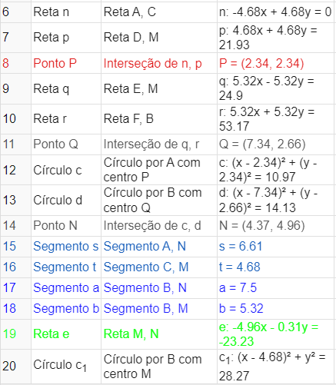

Figure 11. Protocol of the Olympic Teaching Situation performed in GeoGebra

The protocol for this problem situation has aspects related to perimeter and areas of plane figures. The next topic exemplifies another parameterization in GeoGebra.
(c) Find the locus of the midpoints of the segments PQ when M varies between A and B:

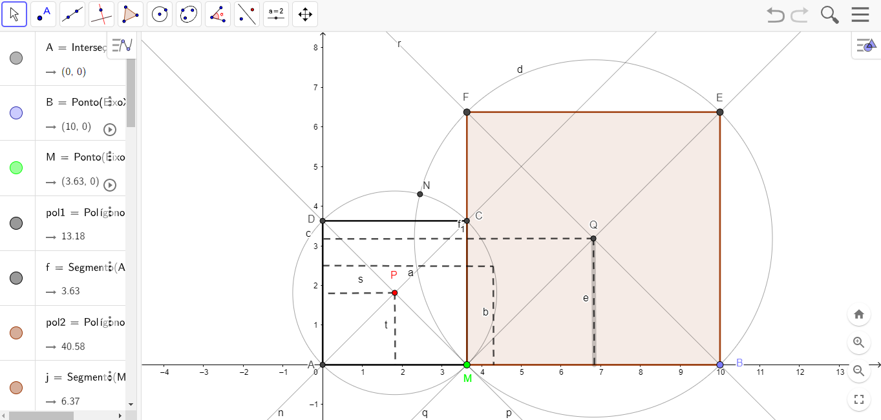

Figure 12. Points intercepted by the quadrilateral MBEF

Denote the midpoint of PQ as R. It is clear that the distance of R from AB is the average of the distances of P and Q from AB, half the length of AB, and is a constant. Therefore, the locus in question is a line segment.

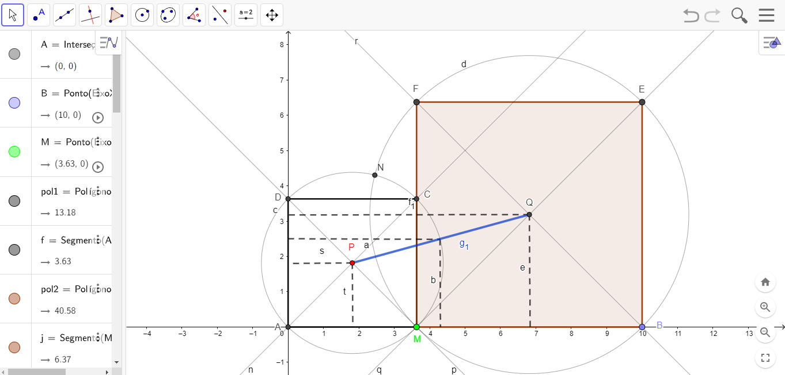

Figure 13. Line segment P and Q intersecting other links of the x and y axis

The representation of the structured commands in GeoGebra is shown in Figure 14, as pictured below:

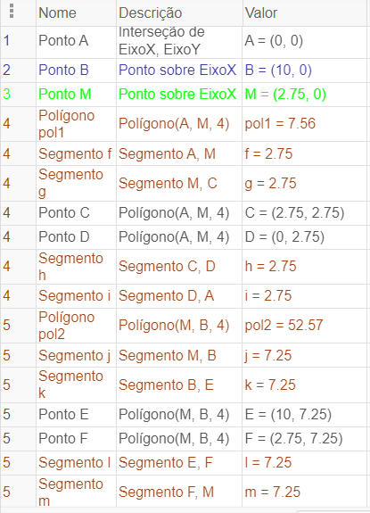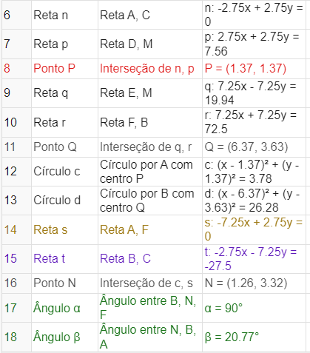

Figure 14. Commands of the construction performed in GeoGebra of the final part of the question

To fix the teaching and learning, it includes these issues in the school curriculum in a well-articulated way, and may be modified depending on the didactic situation to be applied by the teacher with this type of digital educational resource that can make the classroom more dynamic, generating interaction, interest, and commitment from the students.

CONCLUSION
This paper presents the Olympic teaching situation for mathematics teachers to include in the teaching and learning of Plane Geometry, with preference in the inclusion of the Theory of Didactic Situations (TSD) to provide a better conduction in the pedagogical planning of the teacher.
To structure the construction of the mathematical objects of the research, GeoGebra is used to disseminate the knowledge of the Olympic mathematical problem in a practical way in the simplified understanding of the concepts contained in the resolutions of problem situations.
For the selected IMO questions, the use of building mathematical objects in GeoGebra has potential to open possibilities for students to develop strategies to work on other Olympic questions and visualize the mathematical properties related to the Olympic problems, sharing their search for verification with other classmates in the classroom next to the solved problem.
Therefore, this research presents a teaching and learning situation in the actions and discussions throughout the teacher education process, especially in the future teachers' geometric thinking and their skills for classroom use of GeoGebra software with students. It is expected that the different representations and strategies in mathematics teaching and problem solving with GeoGebra software will make the mathematics olympiads enjoyable along with the students' results in each stage of the olympiads.

AUTHOR CONTRIBUTIONS STATEMENT
Author contributions: All authors were involved in concept, design, collection of data, interpretation, writing, and critically revising the article. All authors approve final version of the article. Funding: A pesquisa foi desenvolvida no Brasil e apoiada financeiramente pelo Conselho Nacional de Desenvolvimento Científico e Tecnológico [The research was developed in Brazil and financially supported by the National Council for Scientific and Technological Development]. Declaration of interest: Authors declare no competing interest. Data availability: Data generated or analyzed during this study are available from the authors on request.
REFERENCES
Almouloud, S. A. (2007). Fundamentos da didática da Matemática [ Foundations of Mathematics Didactics]. Editora UFPR, Paraná. Brasil.

Alves, F. R. V. (2021). SITUAÇÃO DIDÁTICA OLÍMPICA (SDO): Aplicações da Teoria das Situações Didáticas para o Ensino de Olimpíadas [OLYMPIC DIDACTIC ITUATION (SDO): Applications of the Theory of Didactical Situations to the Teaching of Olympiads], Revista Contexto & Educação, 36 (113), 116–142.

Artigue, M. (2013). L’impact curriculaire des technologies sur l’éducation mathématique. Revista de Educação Matemática e Tecnologia Iberoamericana, 4(1), 1-4.

Brousseau, G. (1996). Fundamentos e Métodos da Didáctica da Matemática [Foundations and Methods in the Didactics of Mathematics]. (M. J. Figueiredo, Trad.). In J. Brun (Ed.). Didática das Matemáticas, 1, 35-113. Lisboa: Instituto Piaget. (Trabalho original publicado em 1986).

Common National Curriculum Base. (2018). Base Nacional Comum Curricular.

Santiago, P. V. da S. 2021. Olimpíada Internacional de Matemática: Situações didáticas olímpicas no ensino de geometria plana [International Mathematical Olympiad: Olympic teaching situations in plane geometry]. Dissertação (Mestrado Profissional em Ensino de Ciências e Matemática) - Pró-Reitoria de Pesquisa e Pós-Graduação, Universidade Federal do Ceará, Fortaleza.

